

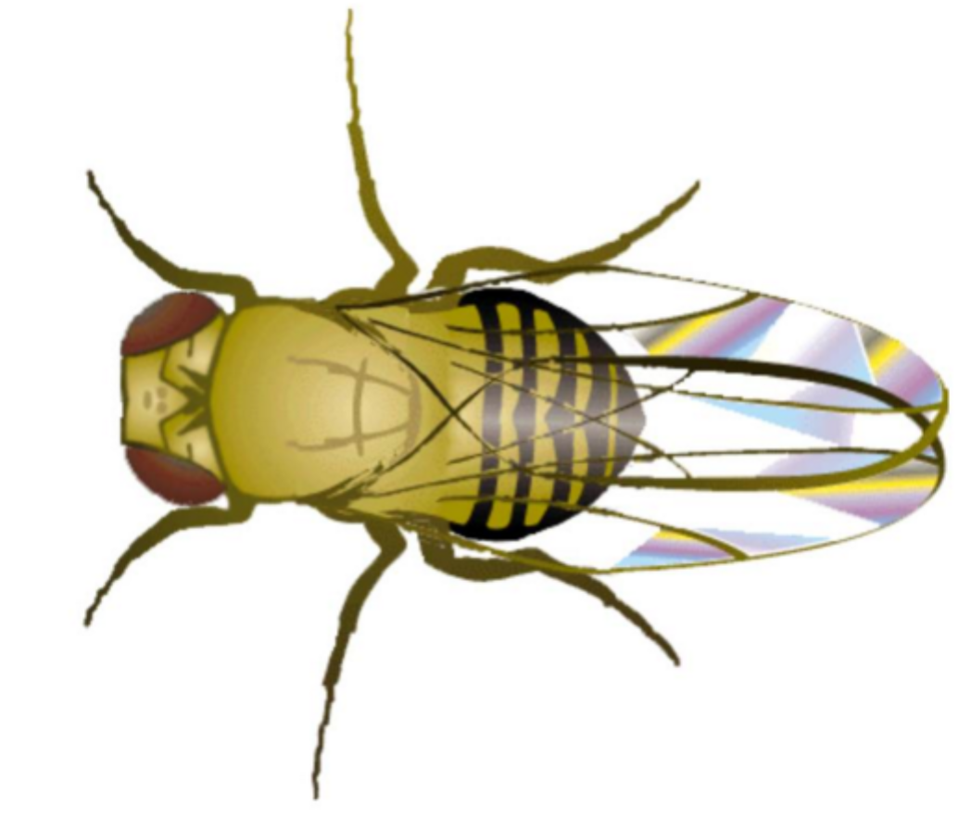
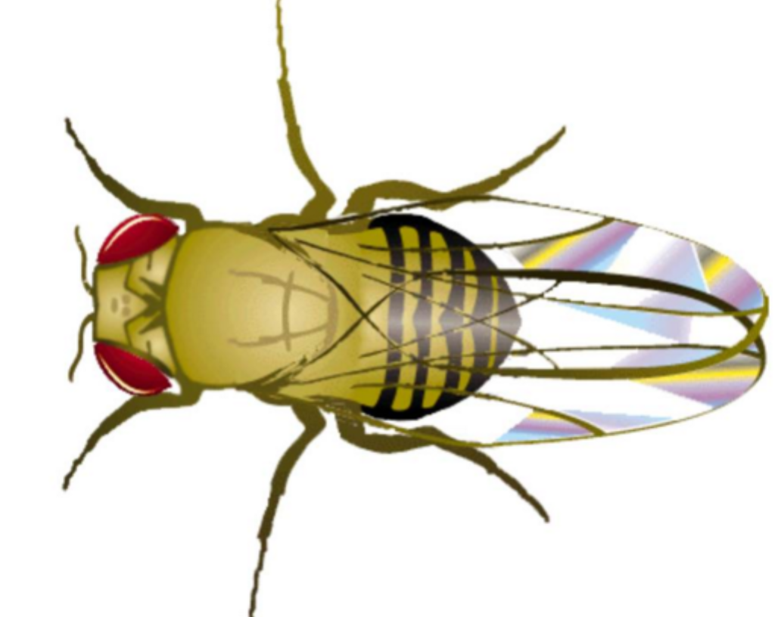
Part 2 – Advanced Nomenclature
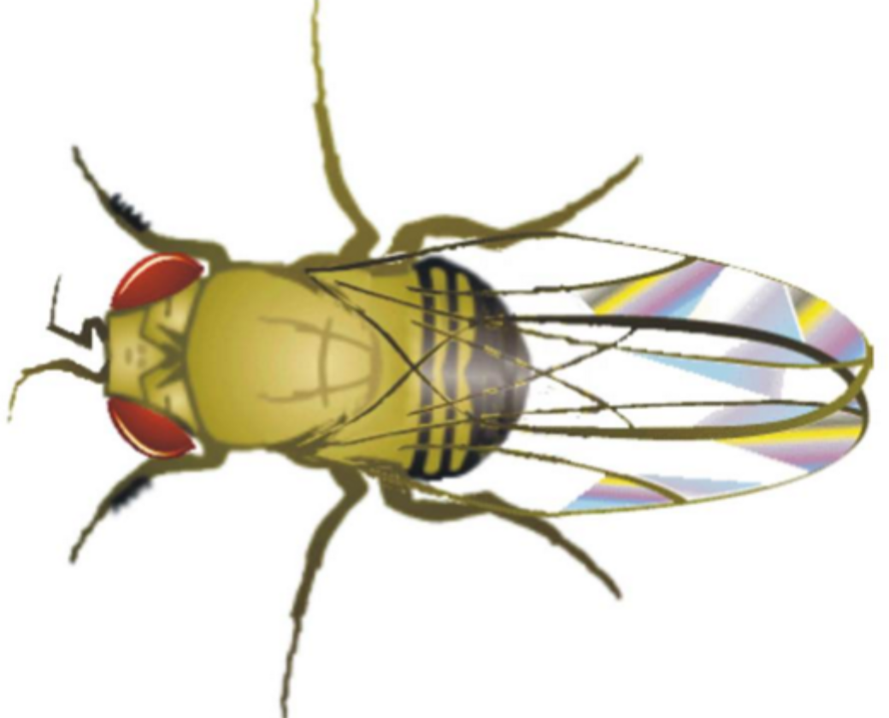 | Figure 1. Wildtype and mutant “flies” of Suminospauci combibo, an imaginary model system. These will be used in this chapter to show how to apply advanced nomenclature.  (Image created by D. Bird based on templates generously provided by The Imaginarium. Used with permission)

Introduction
In Part 1, you saw how several nomenclature systems can be used to communicate the nature of the mutant allele such as its inheritance pattern and whether or not the gene is located on the X-chromosome. This appendix outlines a powerful system that some courses will use to help you practice thinking about genetics like a professional. It’s a strictly-defined method of naming alleles and is designed for you to be able to look at a single gene symbol and determine its inheritance automatically.
Many students find this cumbersome at first. The rules are straightforward, but practice makes this system simple. I’ve had many students report that they hated the system at first, but when using it they found it easier to track the alleles during complex problem solving.

Why Use the Suminospauci combibo System?
In Part 1 you saw different systems of expressing gene inheritance. Some rules we established were:
- Alleles are instructions for a protein. It is the protein that determines the phenotype of a trait.
- Symbols for dominant alleles are capitalized.
- A “+” superscript indicates that an allele is wild-type
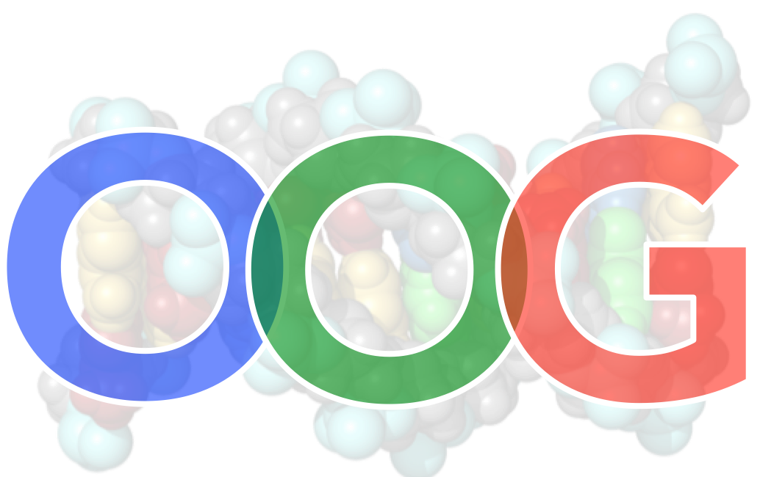
- Some mutant alleles are recessive to wild-type, and some mutant alleles are dominant to their wild-type counterpart.
What’s in a Name?
We noted that if a mutant allele is recessive to the wild-type, and the wild-type allele is dominant to the mutant allele. Conversely, if the mutant allele is “dominant”, the wild-type allele is “recessive”. When writing these things out fully, the descriptions get complex; and the more complex, the more likely you are to make a mistake. Likewise, if you’re writing out a description and start talking about the mutant alleles and switch to the wild-type allele later on, changes are good you’ll confuse the reader – and likely yourself!

Three-letter Symbols
In the other systems, it’s perfectly acceptable to use a single letter or even two letters. Sometimes, though, multiple traits spelled with the same first letter can get confusing. Using three letters for a gene symbol can make it easier to remember what the letters stand for. In fact, for some model systems those who study them adopt a defined nomenclature system: this is the case for certain questions in this course.
This is not unique for this course. For example, a plant often used for genetic studies called Arabidopsis thaliana, has a three-letter code which is required by scientists who want to register a name for their genes (https://www.arabidopsis.org/portals/nomenclature/namerule.jsp).
Just as we saw for the one-letter symbols, the dominant allele has the first letter capitalized and the last two letters are lower-case. Recessive alleles are all lower-case. With three letters, you can make gene names that are easier to keep track of. For example, you might see a fly with an extra set of wings. Instead of calling it “w” for “wings” (which is a poor choice because it doesn’t represent the mutant phenotype), you can instead call it “exw” for “extra wings”. Then, when you see it, you can sound out the abbreviation and remember that it stands for the mutation. If the wild-type allele for this is dominant, then you would write that one “Exw”. The first letter indicates that it is the dominant allele. What you can’t tell just from these examples is that wild-type allele is dominant! Advanced Nomenclature extends this system so you can add that information to the gene symbol. As with all gene symbols, you should underline or italicize the characters.
Three Letter System
When describing the phenotype, use three letters that are all in capital letters and not italicized. Thus, if we know the extra wings is recessive, a fly that is homozygous recessive would have a genotype of exw/exw and a phenotype of EXW. A fly that is heterozygous would be exw⁺/exw and a homozygous dominant fly would be exw⁺/exw⁺. We would not indicate their phenotype because wild-type phenotypes are ignored. The reader will assume all unnamed features are normal.

Autosomes
This lists the rules for Advanced Nomenclature. Some of them should be familiar from Part 1.
- The "normal" phenotype is described as "wildtype"; this is the default phenotype of the reference organism.
- Any change from the wildtype phenotype is a mutation and must be named. The name must provide a clear description of the mutant phenotype. One or two words is best.
- The gene symbol must be 3 letters derived from the trait name. Consider using the first three letters of the name you chose or use the first couple letters and last letter if it makes a word that reminds you of the mutant trait. If you use two words, you could replace the last letter of your symbol with the first letter of the second word.
- Dominant mutant trait symbols must have the first letter capitalized. Recessive mutant traits must be all lower case.
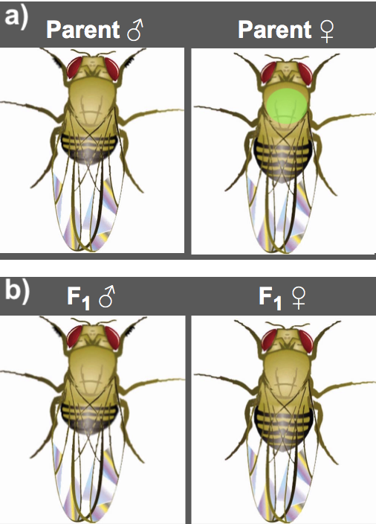
The wild-type allele (that is, the not mutant allele) uses the exact same letters as the mutant: only a superscript ‘+” is added to the symbol.
Figure 2: a) Wild-type male crossed with a mutant female. b) Their F₁ progeny.
An example is shown in Figure 2 at right. Note that the female parent has a green spot on her back. None of the progeny have spots, so the mutant allele causing the coloured spot cannot be dominant. Because the mutant phenotype shows a green spot, we could call this gene “green spot”. A three-letter symbol must therefore start with a lower-case letter because the mutant allele is recessive. Thus we could call it gsp or gns for green spot or even grn for green. All are equally appropriate, so let’s choose gsp to remind us that the symbol stands for green spot. The wild-type allele symbol would be therefore be gsp⁺. If you were asked to diagram the cross using symbols, you could specify the genotypes as:
P: gsp⁺/gsp⁺ x gsp/gsp ; all F₁ offspring: gsp⁺/gsp

Sex Chromosomes
Many species have an additional pair of chromosomes that do not look like a homologous pair. These are sex chromosomes because they differ between the sexes. In humans, males have one of each while females have two X chromosomes. Autosomes are those chromosomes present in the same number in males and females, while sex chromosomes are those that are not. When sex chromosomes were first discovered their function was unknown and the name X was used to indicate this mystery.
For loci on autosomes, the alleles follow the classic Mendelian pattern of inheritance. However, for loci on the sex chromosomes this doesn’t follow because most (not all) of the loci on the typical X-chromosome are absent from the Y-chromosome, even though they act as a homologous pair during meiosis. Instead, they will follow a sex-linked pattern of inheritance. An X-linked allele in the father will always be passed on to his daughters only, but an X-linked allele in the mother will be passed on to both daughters and sons equally.
Note that in the above example, green spot cannot be X-linked because the mother gives her allele to all her sons.

Example of an X-linked gene: the white gene in drosophila melanogaster
A well-studied sex-linked gene is the white gene on the X chromosome of Drosophila melanogaster. Normally flies have red eyes, but flies with a mutant allele of this gene called white have white eyes because the red pigments are absent. Because this mutation is recessive to the wild type allele, females that are heterozygous have normal red eyes. Female flies that are homozygous for the mutant allele have white eyes. Because there is no white gene on the Y chromosome, male flies can only be hemizygous for the wild type allele or the mutant allele, and consequently express that phenotype. You already know that the mutant allele causes a white phenotype and is that it is recessive due to its name, white.
Figure 3: a white-eyed mutant male crossed with a wild type female produces offspring that all appear wild-type.
You can see data that show that white is X-linked and recessive in Figures 3 and 4. Morgan first found a new mutation in his stock line; a male that had white eyes. When he bred this fly with a wild-type female, all progeny had red eyes and it was clear the mutant allele is recessive (Figure 3). If all you had was the information in Figure 3, you might think that the gene for white is autosomal.
Figure 4: Morgan's reciprocal cross from what you saw in Figure 3.
In Morgan’s studies, however, when the F₁ generation was crossed to make an F₂, a strange phenomenon occurred: all females had red eyes, but half the males had white eyes and the other half had red eyes. Morgan crossed white eyed males with his F1 females (note this is a testcross!), and the offspring consisted of 25% white eyed males, 25% red eyed males, 25% white eyed females and 25% red eyed females (a 1:1 ratio as expected!). Just for exercise, consider why the “testcross” in Figure 2 did not show a 1:1 ratio! Clearly, something is different in the inheritance pattern of the white gene when you compare it to green spot. Morgan quickly created a genetic model where white is on the X-chromosome, which is visibly different from the Y chromosome in male flies (and in humans!).
A careful geneticist, Morgan took one of his white-eyed females and used her in a number of crosses. If two white-eyed flies are crossed, all offspring have white eyes. But when he crossed a white-eyed female with a wild-type male (a reciprocal cross from the one shown in Figure 3), all male flies had white eyes and all females had red-eyes (Figure 3).
With this information, we must now specify that white is on the X-chromosome, and that is a mandatory component of the gene symbol. We will use three letters as a superscript to the right of the X symbol; the mutant allele is X^{whi} and wild type is X^{whi+}. Males are hemizygous for white, and so we will include the Y chromosome in his genotype. The genotypes in Figure 4 are:
P: X^{whi+}/Y x X^{whi}/X^{whi} ; F₁ males: X^{whi}/Y & F₁ females: X^{whi+}/X^{whi}

The letter “X” states that this is a gene on the X chromosome, and the superscript identifies the gene as one in which the mutant phenotype is “whi” (“short for white”). Caution: do not indicate anywhere that whi is a symbol for white; always keep the X as part of the symbol. Whenever you indicate whi, you are stating explicitly that this is an autosomal gene.
Indicating X-linkage

Rules for symbols for more than one X-linked gene
Figure 5: Indicate the F₁ female genotype
If there are multiple genes on the X-chromosome, they appear as consecutive superscripts. Only one “X” symbol is used for each X chromosome. For example, if there is another locus on the X chromosome containing a dominant mutant allele that gives rise to abdominal spikes, you could specify a cross between a female heterozygous for spikes and a male that has white eyes as:
P: X^{whi Spi+} /Y x X^{whi+ Spi+}/X^{whi+ Spi}
Note that we assume that the male is hemizygous for not having abdominal spikes (thus has the wild-type allele) and the female is homozygous for the wild-type eye colour.

Y-linked gene
Genes located on the Y-chromosome exhibit Y-linkage. For examples, the TDF gene has a recessive mutant allele that is responsible for a hairy ear rim phenotype show only father-to-son inheritance patterns. These genes are extremely rare and illustrate holandric inheritance. If such an unusual situation were to be presented, the gene would be illustrated as such: Y^{her}.
Personally, I would find it distracting to have a holandric gene that says “her” when I read it … it would confuse me so I would probably choose Y^{hem} to keep myself straight. That’s the best use of symbols; something that helps you keep track of the alleles when you sound them out as you work through the genetic models.
___________________________________________________________________

Summary:
- In some situations a specific nomenclature system must be used. In this course, the Advanced Nomenclature may be requested and must be followed exactly.
- Advanced Nomenclature always uses three letters that are based on the mutant phenotype.
  - Phenotypes are only indicated if mutant and use non-italicized capital letters based on the gene symbol.
  - Recessive alleles have all lower-case letters.
  - Dominant alleles have the first letter capitalized followed by 2 lower-case.
  - X-linked genes always include the symbol X and the three letter code.
- The F₁ female genotype in Figure 5 is X^{whi+}/X^{whi}; gsp⁺/gsp.

