Chapter 2 – Mendel’s Laws

Part 1 - Mendel’s First Law: Segregation of Alleles
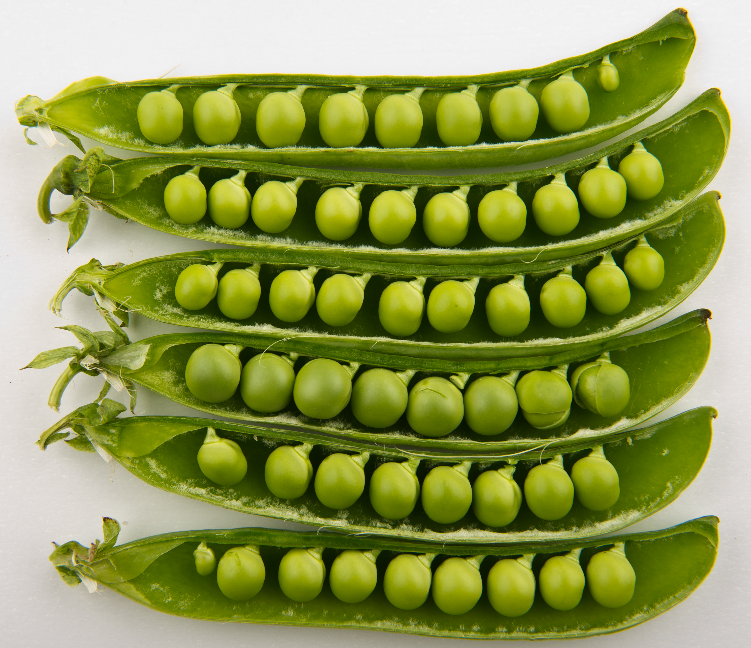 | Figure 1.  Pea plants were used by Gregor Mendel to discover fundamental laws of genetics.  His first law, the segregation of alleles, is covered in this chapter. His second law, independent assortment, is covered in the next chapter. (Wikimedia commons-B. Ebbesen-CC BY-SA 3.0)

Introduction
The once prevalent concept of blended inheritance proposed that some undefined essence, in its entirety, contained all of the heritable information for an individual. It was thought that mating combined the essences from each parent, much like the mixing of two colors of paint. Once blended together, the individual characteristics of the parents could not be separated again. It was just “common sense”.
However, Gregor Mendel (Figure 2) was one of the first to take a quantitative, scientific approach to the study of heredity. He started with well-characterized strains, repeated his experiments many times, and kept careful records of his observations. Working with peas, Mendel showed that white-flowered plants could be produced by crossing two purple-flowered plants, but only if the purple-flowered plants themselves had at least one white-flowered parent (Figure 3). This was evidence that a discrete genetic factor that produced white-flowers had not blended irreversibly with the factor for purple-flowers. Mendel’s observations disprove blending inheritance and favor an alternative concept, called particulate inheritance, in which heredity is the product of discrete factors that control independent traits.
Because of this work, blended inheritance was discredited as a theory of inheritance.
Through careful study of patterns of inheritance, Mendel recognized that a single trait could exist in different versions, or alleles, even within an individual plant or animal. For example, he found two allelic forms of a gene for seed color: one allele gave green seeds, and the other gave yellow seeds. Mendel also observed that although different alleles could influence a single trait, they remained indivisible and could be inherited separately. This is the basis of Mendel’s First Law, also called The Law of Equal Segregation, which states: during gamete formation, the two alleles at a gene locus segregate from each other; each gamete has an equal probability of containing either allele.

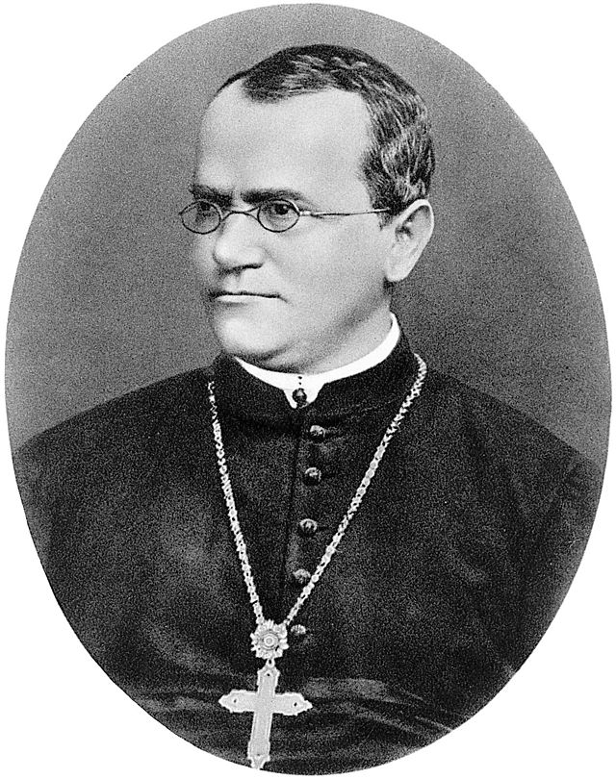
Figure 2.
Gregor Johann Mendel (1822-1884), an Augustinian Friar, who lived in Moravia (now part of the Czech Republic), published his work in 1866 on what has become known as the laws of Mendelian Inheritance.
(Wikipedia-Hugo Iltis- CC BY 4.0)

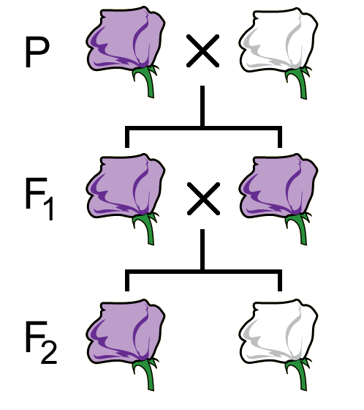
Figure 3.
Inheritance of flower color in peas. Mendel observed that a cross between pure breeding, white and purple peas (generation P) produced only progeny (generation F₁) with purple flowers. However, white flowered plant reappeared among the F₂ generation progeny of a mating between two F₁ plants. The symbols P, F₁ and F₂ are abbreviations for parental, first filial, and second filial generations, respectively. (Original-Deyholos- CC BY-NC 3.0)

Overview
Mendel first made his discoveries of inheritance in the 1850’s. In his 1866 publication he didn’t use the word “gene” as the fundamental unit of heredity because it wasn’t coined until 1909 by Danish botanist Wilhelm Johannsen. Thomas Hunt Morgan proposed that genes resided on chromosomes in 1910, and occupied distinct regions on those chromosomes. DNA as a substance was discovered in the 1860’s, but it took until the 1940s to realize that DNA was the molecule that contained the genetic information. Then in the 1950’s Watson and Crick discovered the structure of DNA.
Nevertheless, Mendel made his discoveries without any of this information. Today we have overwhelming knowledge from research allowing us to understand the molecular mechanism behind Mendel’s laws. To explain Mendel’s First Law, segregation, we will explain it through the concept of Meiosis.

Dominant and recessive alleles
The concepts of dominant and recessive alleles were introduced in Chapter 1 and Appendix 1. Remember, alleles are different versions of a gene. The traits Mendel studied with his peas were all completely dominant traits, and so will only be described briefly here.
In a diploid organism, if an allele is dominant only one copy of that allele is necessary to see the dominant phenotype. If an allele is recessive, then the gene needs to have two copies (or be homozygous) to see the recessive phenotype. If an organism is a heterozygote, or has one copy of each allele type, then it will show the dominant phenotype. When representing these in written form, a dominant allele is written as a capital letter (e.g. A), while a recessive allele will be written in lower case (e.g. a). If these are alleles of the same gene, they should be written with the same letter. This is the most common way of writing genotypes (See AppeTable 1 in Chapter 1), but there are many different systems.

that often have deviations from these general rules. Note that genes and alleles are usually written in italics and chromosomes and proteins are not, proteins often written in all capitals. For example, the white gene in Drosophila melanogaster on the X chromosome encodes a protein called WHITE.

One Locus on a Chromosome - Segregation - Monohybrid
Not only did Mendel solve the mystery of inheritance as units (genes), he also invented several testing and analysis techniques still used today. Classical genetics is the science of solving biological questions using controlled matings of model organisms. It began with Mendel in 1865 but did not attain wide spread usage until Mendel’s work was rediscovered in 1903 by four researchers (E. von Tschermak, H. de Vries, C. Correns, and W. J. Spillman). Then Thomas Morgan began working with fruit flies in 1908 and used this work. Later, starting with Watson and Crick’s structure of DNA in 1953, classical genetics was joined by molecular genetics, the science of solving biological questions using DNA, RNA, and proteins isolated from organisms. The genetics of DNA cloning began in 1970 with the discovery of restriction enzymes and plasmids as cloning vectors.
Knowing what we now know of the process of meiosis, we can further understand what Mendel’s First Law means. The Law of Segregation states that every individual contains a pair of alleles for each gene, which segregate during the creation of gametes, and so for every gene pair each parent passes on a random allele to its offspring. The way Mendel decided on his First Law was through the process of Monohybrid crosses, which will be described below.

Terminology
A specific position along a chromosome is called a locus. Each gene occupies a specific locus (so the terms locus and gene are often used interchangeably). Each locus will have an allelic form (allele). The complete set of alleles (at all loci of interest) in an individual is its genotype. Typically, when writing out a genotype, only the alleles at the locus (loci) of interest are considered – all the others are present and assumed to be wild type but are normally not written in the genotype. The visible or detectable effect of these alleles on the structure or function of that individual is called its phenotype – what the individual looks like. The phenotype studied in any particular genetic experiment may range from simple, visible traits such as hair color, to more complex phenotypes including disease susceptibility or behavior. If two alleles are present in an individual, then various interactions between them may influence their expression in the phenotype.

True breeding lines
Geneticists make use of true breeding lines just as Mendel did (Figure 8a). These are in-bred populations of plants or animals in which all parents and their offspring (over many generations) have the same phenotypes with respect to a particular trait. True breeding lines are useful, because they are typically assumed to be
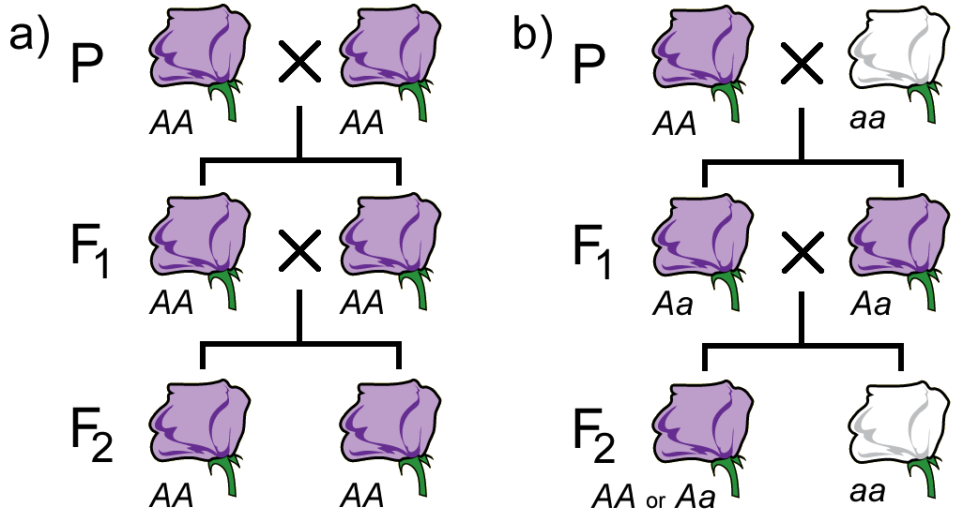
Figure 8.
(a) A true-breeding line (b) A monohybrid cross produced by mating two different pure-breeding lines.
(Original-Deyholos-CC BY-NC 3.0)
homozygous for the alleles that affect the trait of interest. When two individuals that are homozygous for the same alleles are crossed, all of their offspring will all also be homozygous. The continuation of such crosses constitutes a true breeding line or strain. A large variety of different strains, each with a different, true breeding character, can be collected and maintained for genetic research.

Monohybrid crosses
A monohybrid cross is one in which both parents are heterozygous (or a hybrid) for a single (mono) trait. The trait might be petal colour in pea plants (Figure 8b). Recall from Figure 3 that the generations in a cross are named P (parental), F₁ (first filial), F₂ (second filial), and so on.
The monohybrid cross is how Mendel discovered genes were discrete units that separated in the creation of offspring. Previous ideas of blending inheritance would mean that a cross between a white flower and a purple flower would create a ‘blended’ phenotype. Instead what Mendel saw was distinct parental colours in the hybrids, that when crossed would produce in specific ratios the purple and white seen in the parents. These traits weren’t blended when the true-breeding lines were crossed, but instead those parental alleles were carried on through the offspring. Through the monohybrid cross he was able to discern the dominant and recessive alleles of each gene he studied in the pea plants. In further crosses (F_{3,} F₄, etc.), these traits were continuously transmitted and not lost, though they may be hidden as seen in the F₁ generation.

Punnett Squares - 3:1 Ratio
The specific ratios seen in the monohybrid cross can be described using a Punnett square, named after R.C. Punnett who devised this approach.
Given the genotypes of any two parents, we can predict all of the possible genotypes of the offspring. Furthermore, if we also know the dominance relationships for all of the alleles, we can predict the phenotypes of the offspring. This provides a convenient method for calculating the expected genotypic and phenotypic ratios from a cross.
A Punnett square is a matrix in which all of the possible gametes produced by one parent are listed along one axis, and the gametes from the other parent are listed along the other axis. Each possible combination of gametes is listed at the intersection of each row and column, since we know through the process of meiosis that the alleles on each chromosome separate to form the gametes.
The F₁ cross from Figure 8b would be drawn as in Figure 9. As you can see, in a Monohybrid cross, the offspring ratios will be 3:1 of dominant phenotype (purple): recessive phenotype (white). Punnett squares can also be used to calculate the frequency of offspring. The frequency of each offspring is the frequency of the male gametes multiplied by the frequency of the female gamete.
Figure 9.
A Punnett square showing a monohybrid cross. The purple boxes represent the purple colour of the dominant (A) allele, while the white box represents the recessive (aa) allele homozygote. (Original-L. Canham- CC BY-NC 3.0)

Figure 10.
Punnett squares showing the two possible outcomes of a single locus test cross. (Original-L. Canham- CC BY-NC 3.0)

Single locus Test Crosses
Knowing the genotypes of an individual is an important part of a genetic experiment. However, genotypes cannot be observed directly; they must be inferred based on phenotypes. Because of dominance, it is often not possible to distinguish between a heterozygote and a homozygote based on phenotype alone (e.g. see the purple-flowered F₂ plants Figure 8b). To determine the genotype of a specific individual, a test cross can be performed, in which the individual with an uncertain genotype is crossed with an individual that is homozygous recessive for all of the loci being tested.
For example, if you were given a pea plant with purple flowers it might be a homozygote (A/A) or a heterozygote (A/a). You could cross this purple-flowered plant to a white-flowered plant as a tester, since you know the genotype of the tester is a/a. Depending on the genotype of the purple-flowered parent (Figure 10), you will observe one of two phenotypic ratios in the F₁ generation. If the purple-flowered parent was a homozygote AA, all of the F₁ progeny will be purple. If the purple-flowered parent was a heterozygote A/a, the F₁ progeny should segregate purple-flowered and white-flowered plants in a 1:1 ratio.

___________________________________________________________________________

Summary:
- Mendel demonstrated that heredity involved discrete, heritable factors that affected specific traits.
- A gene can be defined abstractly as a unit of inheritance.
- Phenotype depends on the alleles that are present, their dominance relationships, and sometimes also interactions with the environment and other factors.
- Classical geneticists make use of true breeding lines, monohybrid crosses, Punnett squares, test crosses, reciprocal crosses, and the chi-square test.

Key terms:

blending inheritance
Gregor Mendel
particulate inheritance
alleles
Mendel’s First Law
The Law of Equal Segregation
dominant
recessive
polar bodies
classical genetics
molecular genetics
DNA cloning
monohybrid cross
locus
genotype
phenotype
true breeding lines
Punnett square
test cross
tester

Study Questions:

- How would the results of the cross in Figure 3 have been different if heredity worked through blending inheritance rather than particulate inheritance? If the F₁ was selfed, how would successive generations appear? What in particular did Mendel’s work demonstrate regarding the nature of whatever particle determined inheritance?
- Imagine that astronauts provide you with living samples of multicellular organisms discovered on another planet. These organisms reproduce with a short generation time, but nothing else is known about their genetics.
  - How could you define laws of heredity for these organisms?
  - How could you determine what molecules within these organisms contained genetic information?
  - Would the mechanisms of genetic inheritance likely be similar for all organisms from this planet?
  - Would the mechanisms of genetic inheritance likely be similar to organisms from Earth?
- Wiry hair (W) is dominant to smooth hair (w) in dogs.
  - If you cross a homozygous, wiry-haired dog with a smooth-haired dog, what will be the genotype and phenotype of the F1 generation?
  - If two dogs from the F1 generation mated, what would be the most likely ratio of hair phenotypes among their progeny?
  - When two wiry-haired W/w dogs actually mated, they had a litter of three puppies, which all had smooth hair. How do you explain this observation?
  - Someone left a wiry-haired dog on your doorstep. Without extracting DNA, what would be the easiest way to determine the genotype of this dog?
  - Based on the information provided in question 1, can you tell which, if either, of the alleles is wild-type?
- An important part of Mendel’s experiments was the use of homozygous lines as parents for his crosses. How did he know they were homozygous, and why was the use of the lines important?

Part 2 - Mendel’s Second Law: Independent Assortment
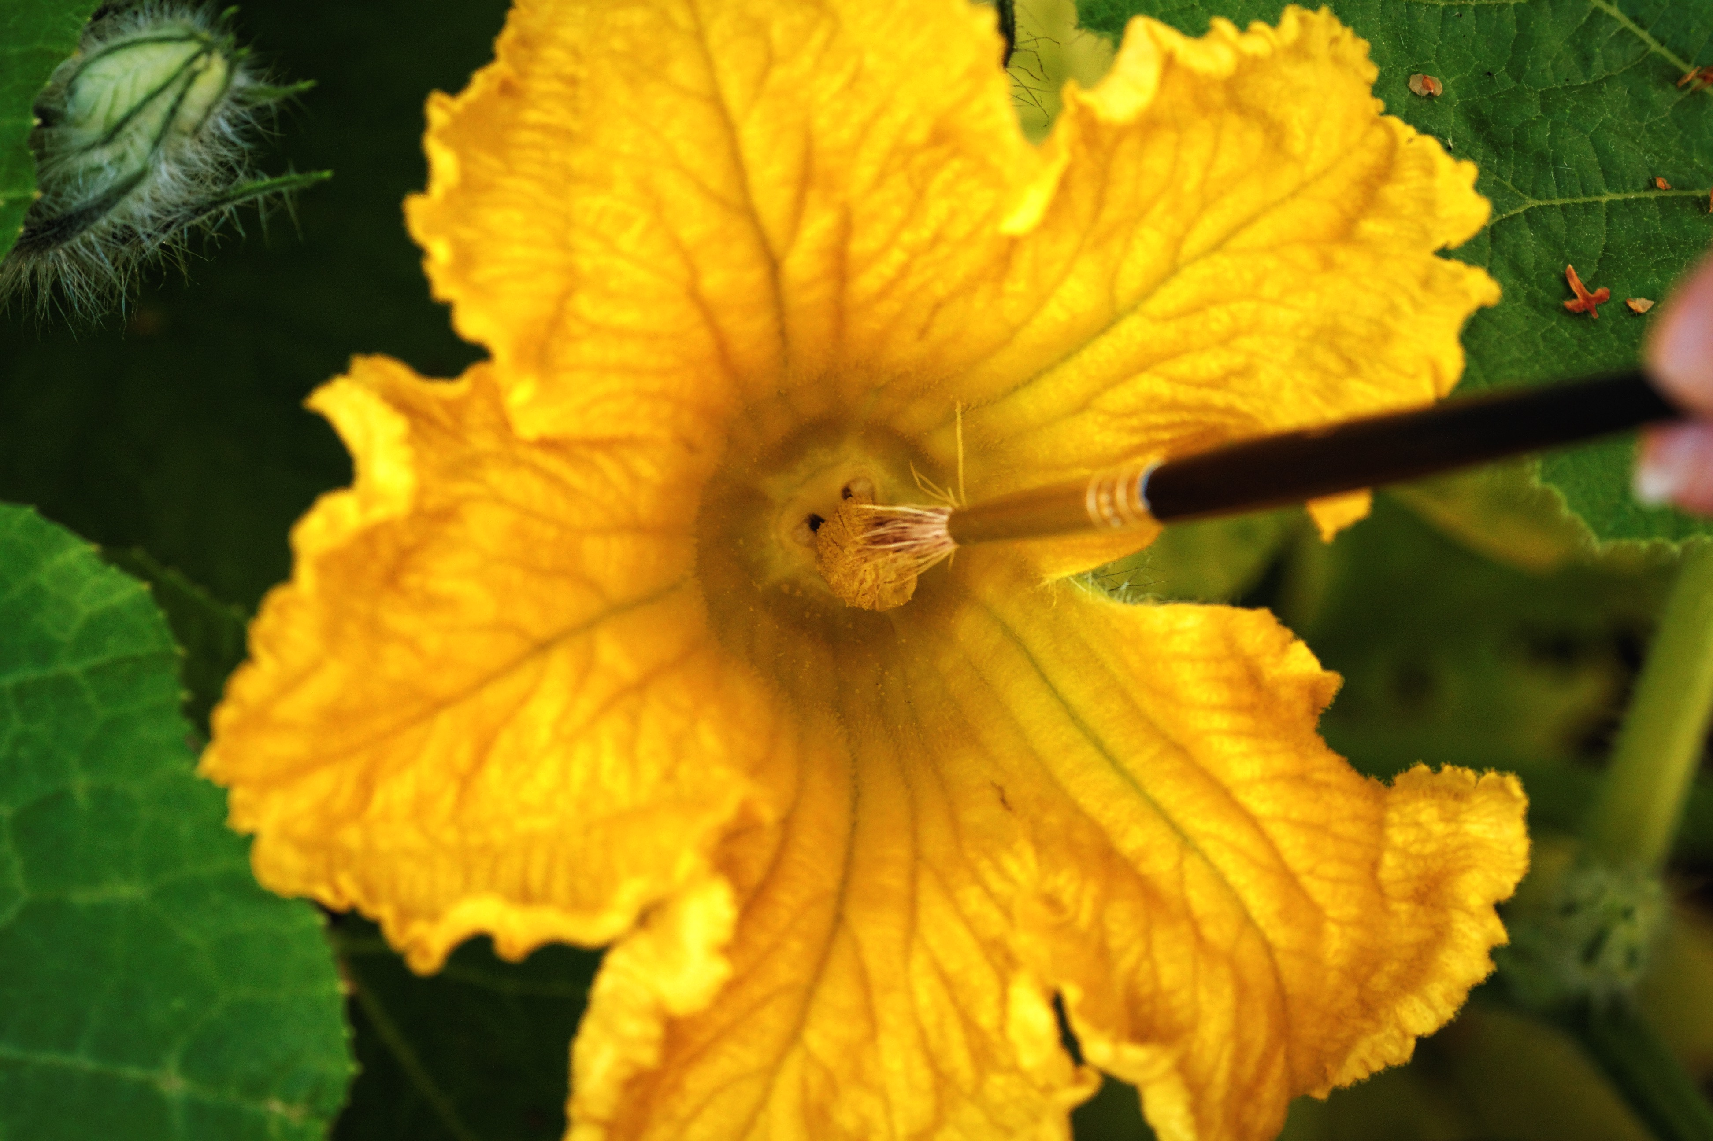 | Figure 7.  Hand pollination of a pumpkin flower. When Mendel was doing his crosses with pea plants, he pollinated each flower by hand in a similar way in order to be sure he knew the parents of each cross.  (Flickr-S. Hurmerinta- CC BY-NC 2.0

Introduction
The principles of genetic analysis that we have described for a single locus in Chapter 1 will be extended to the study of alleles at two loci in this Chapter. The analysis of two loci in the same cross provides information for genetic mapping (Chapter 9) and testing gene interactions (Chapter 5). These techniques are very useful for both basic and applied research. Before discussing these techniques, we will first revisit Mendel’s classical experiments.
Before Mendel’s 1865 publication, blended inheritance was the accepted model to explain the transmission of traits. It was Mendel’s work that established that heritable traits were controlled by discrete factors, which we now call alleles, in a particulate inheritance model. At the time it was an important question as to whether heritable traits, controlled by discrete factors, were inherited independently of each other? To answer this, Mendel took two apparently unrelated traits, such as seed shape and seed color, and studied their inheritance together in one individual. For example, he studied two variants of each trait: seed color was either green or yellow, and seed shape was either round or wrinkled. (He studied seven traits in all, each on a different chromosome.) When either of these traits was studied individually, the phenotypes segregated in the classical 3:1 ratio among the progeny of a monohybrid cross (Figure 8), with ¾ of the seeds green and ¼ yellow in one cross, and ¾ round and ¼ wrinkled in the other cross. Would this be true when both hybrids were in the same individual?
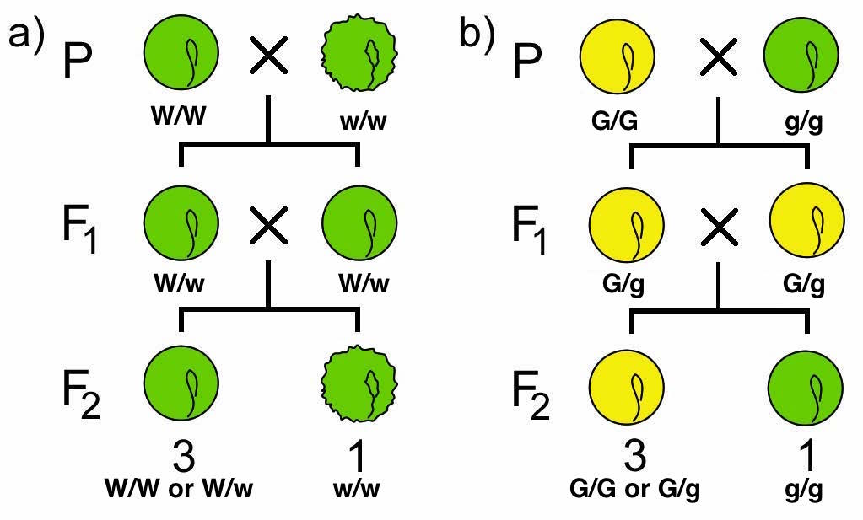
Figure 8.
Monohybrid crosses involving two distinct traits in peas. a) is W/w and b) is G/g. Note that seeds in a) also contain a “g” gene that would be homozygous recessive, but this isn’t written out. Seeds in b) are have a “w” gene, but they would be heterozygous or homozygous dominant. By convention, unless a gene is specifically referenced in the problem, we don’t write it down – but it’s still there!
Monohybrid crosses are detailed in Chapter 2
(Original-Deyholos-CC BY-NC 3.0-Modified-Nickle)
Like in the previous chapter, we will first walk through how a dihybrid cross works on at the DNA level, and then we will explain the results that Mendel saw that led him to his law, the Law of Independent Assortment.

Two Loci on Different Chromosomes
The separation of gametes through the process of meiosis has already been introduced. But what does that mean when you are taking multiple different genes (or loci) into account?
Remember the main stages of meiosis. The homologous pairs align during metaphase I, and complete one round of cell division. Then during metaphase II in those two cells the replicated chromosomes align individually and the sister chromatid separate, so when complete you have two daughter cells. Let’s say one chromosome has Gene A on it, and another chromosome has Gene B on it, and the individual is heterozygous at each gene (a.k.a. has the genotype A/a ; B/b). There are a variety of ways that the homologous pairs can align themselves during metaphase I. The orientation of that alignment will affect the alleles each gamete receives at the end of telophase II (Figure 9).
Because the alignment at metaphase I is always random you will see a random, equal distribution of alleles in all the gametes produced. This means that one allele doesn’t affect the distribution of another allele, or in other words, each allele assorts independently (Independent Assortment).

Two Loci on One Chromosome
Based on the description in the last section, it would be expected that if the genes were on the same chromosome the alleles would travel together through meiosis (Figure 10 top). However, when tested this is not always the case. The recombination of alleles can be explained through the phenomenon of crossing over, which occurs during prophase I as was described in chapter 16. Crossing over is an exchange between non-sister chromatids that can occur at any position along the entire chromosome. If the two loci being observed are sufficiently far enough apart on the chromosome, crossover events can occur between the two loci.

Figure 9.
Independent assortment as seen on two different chromosomes. Gene A is found on the short chromosome and Gene B is found on the long chromosome, and both genes are heterozygotes for the dominant (A and B) and recessive (a and b) alleles. The orientation that the chromosomes align themselves during metaphase I affect the alleles found in the 4 gametes produced after telophase II.
These are just two of many orientations the chromosomes can arrange themselves in at metaphase I. The full stages of meiosis were removed for simplicity; refer to chapter 16 to understand the divisions that lead to the 4 gametes seen in telophase II. (Original-L.Canham-CC BY-NC 3.0)
This coupled with the random orientation that the chromosomes align during metaphase I, will allow the other combination of alleles in the gametes (Figure 10 bottom).
While not shown in Figure 10, if the two loci are very far apart, multiple crossover events can also take place, further increasing the shuffling of alleles.
Figure 10.
Independent assortment as seen on the same chromosome. On the top is an example of what would happen in crossovers did not take place. The dominant alleles of Gene A and Gene D would always travel together, not leading to independent assortment. Crossovers do occur in most situations though, like in the bottom half of the figure. If a crossover occurs between the two genes, then the alleles will transfer to the other non-sister chromatid causing a shuffling of alleles. This allows for independent assortment, despite being on the same chromosome.
This is just one of the many arrangements or crossover events that can occur during meiosis, with every meiocyte arranging themselves differently with different crossovers. (Original-L.Canham-CC BY-NC 3.0)
The farther apart on the chromosome the more crossover events take place between the two loci. Ultimately, this will result in similar allele combinations to that observed in independent assortment shown above, even if they are on the same chromosome.
If the loci are very close together on the same chromosome, fewer or no crossovers will occur between them. We will not take this situation into account in this chapter, but will be discussed later in chapter 18.

A Dihybrid Cross showing Mendel’s Second Law (Independent Assortment)
Mendel found for each locus that there were two alleles, which segregated from each other during the creation of gametes. He wondered if dealing with multiple traits at a time would affect this segregation, so he created a dihybrid cross. The distribution of offspring from his experiments led him to formulate Mendel’s Second Law, the Law of Independent Assortment, which states that the segregation of alleles as one locus will not influence the segregation of alleles at another locus during gamete formation – the alleles segregate independently. Next we will walk through how he came to this understanding, now that it’s already been explained how independent assortment happens.

Mendel’s second law
To analyze the segregation of both traits at the same time in the same individual, he crossed a pure breeding line of green, wrinkled peas with a pure breeding line of yellow, round peas to produce F₁ progeny that were all green and round. They were called dihybrids in that they carried two alleles at each of two loci (Figure 11)
If the inheritance of seed color was truly independent of seed shape, then when the F₁ dihybrids were crossed to each other, a 3:1 ratio of one trait should be observed within each phenotypic class of the other trait (Figure 11). From Figure 8 we know that yellow and round are dominant, and green and wrinkled are recessive. Using the product law, we would therefore predict that if ¾ of the progeny were yellow, and ¾ of the progeny were round, then ¾ × ¾ = 9/16 of the progeny would be both round and yellow (Table 1).
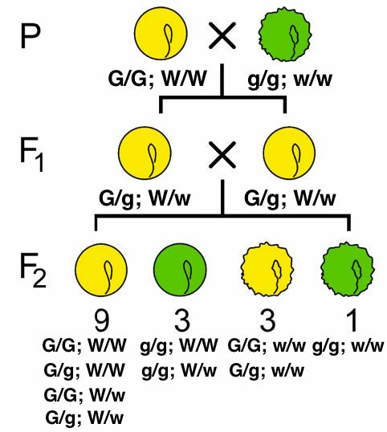
Figure 11.
Two pure-breeding lines are crossed to produce dihybrids in the F1 generation. These F1 are crossed to produce four phenotypic classes, which appear in a 9:3:3:1 ratio.
(Original-Deyholos-CC BY-NC 3.0 modified by Nickle)

 | W ; G | W ; g | w ; G | w ; g
W ; G | W/W;  G/G | W/W; G/g | W/w; G/G | W/w; G/g
W ; g | W/W; G/g | W/W; g/g | W/w; G/g | W/w; g/g
w ; G | W/w; G/G | W/w; G/g | w/w; G/G | w/w; G/g
w ; g | W/w; G/g | W/w; g/g | w/w; G/g | w/w; g/g

Figure 12.
A Punnett Square showing the results of the dihybrid cross from Figure 11. Each of the four phenotypic classes is represented by a different color of shading. (Original-Nickle-CC BY-NC 3.0)
Likewise, ¾ × ¼ = 3/16 of the progeny would be both round and green. And ¾ × ¼ = 3/16 of the progeny would be both wrinkled and yellow. And ¼ × ¼ = 1/16 of the progeny would be both wrinkled and green. So by applying the product rule to all of these combinations of phenotypes, we can predict that if the two loci assort independently in a 9:3:3:1 phenotypic ratio among the progeny of this dihybrid cross, if certain conditions are met (see section below). Indeed, 9:3:3:1 is very close to the ratio Mendel observed in his studies of dihybrid crosses, leading him to state his Second Law, the Law of Independent Assortment.
The 9:3:3:1 phenotypic ratio that we calculated using the product rule could also be obtained using Punnett Square (Figure 12). First, we list the genotypes of the possible gametes along each axis of the Punnett Square. In a diploid with two heterozygous genes of interest, there are up to four combinations of alleles in the gametes of each parent. The gametes from the respective rows and column are then combined in the each cell of the array. When working with two unlinked loci, genotypes are written with the symbols for both alleles of one locus, followed by both alleles of the next locus (e.g. AaBb, not ABab). Note that the order in which the loci are written does not imply anything about the actual position of the loci on the chromosomes.
To calculate the expected phenotypic ratios, we assign a phenotype to each of the 16 genotypes in the Punnett Square, based on our knowledge of the alleles and their dominance relationships.

Frequency of phenotypic crosses within separate monohybrid crosses:
seed shape: ¾ round ¼ wrinkled
seed color: ¾ yellow ¼ green
Frequency of phenotypic crosses within a dihybrid cross:
¾ round × ¾ yellow = 9/16 round & yellow
¾ round × ¼ green = 3/16 round & green
¼ wrinkled × ¾ yellow = 3/16 wrinkled & yellow
¼ wrinkled × ¼ green = 1/16 wrinkled & green
Table 1.
Phenotypic classes expected in monohybrid and dihybrid crosses for two seed traits in pea.

In the case of Mendel’s seeds, any genotype with at least one W allele and one G allele will be round and yellow; these genotypes are shown in the nine, green-shaded cells in Figure 12. We can represent all of four of the different genotypes shown in these cells with the notation (W/-;G/-), where the dash line (-), means “any allele”. The semicolon means that the genes assort independently (Perhaps they are on different chromosomes). The three offspring that have at least one R allele and are homozygous recessive for y (i.e. R/-;y/y) will have a round, green phenotype. Conversely the three progeny that are homozygous recessive r, but have at least one Y allele (r/r;Y/-) will have wrinkled, yellow seeds. Finally, the rarest phenotypic class of wrinkled, yellow seeds is produced by the doubly homozygous recessive genotype, r/r;y/y, which is expected to occur in only one of the sixteen possible offspring represented in the square.

Assumptions of the 9:3:3:1 ratio
Both the product rule and the Punnett Square approaches showed that a 9:3:3:1 phenotypic ratio is expected among the progeny of a dihybrid cross such as Mendel’s R/r;Y/y × R/r;Y/y. In making these calculations, we assumed that:
(1) alleles at each locus segregate independently of the alleles at the other;
(2) one allele at each locus is completely dominant (the other recessive); and
(3) each of four possible phenotypes can be distinguished unambiguously, with no interactions between the two genes that would interfere with determining the genotype correctly.
For simplicity, most student examples involve easily scored phenotypes, such as pigmentation or changes in visible structures. However, keep in mind that the analysis of segregation ratios of any two markers can provide insight into a wide range of biological processes they may represent.

Deviations from the 9:3:3:1 phenotypic ratio
There can be deviations from the 9:3:3:1 phenotypic ratio. These situations may indicate that one or more of the above conditions has not been met. Modified ratios in the progeny of a dihybrid cross can therefore reveal useful information about the genes involved. One such example is linkage.
Linkage is one of the most important reasons for distortion of the ratios expected from independent assortment. Two loci show linkage if they are located close together on the same chromosome. This close proximity alters the frequency of allele combinations in the gametes. We will return to the concept of linkage in Chapter 9. Deviations from 9:3:3:1 ratios can also be due to interactions between genes, such as epistasis, duplicate gene action and complementary gene action. These interactions are discussed in Chapter 5.

The Dihybrid Test Cross
While the cross of an F₁ x F₁ gives a ratio of 9:3:3:1, there is a better, easier cross to test for independent assortment: the dihybrid test cross. In a dihybrid test cross, independent assortment is seen as a ratio of 1:1:1:1, which is easier to score than the 9:3:3:1 ratio. This test cross will also be easier to use when testing for linkage (Chapter 9).
Like in monohybrid crosses (Part1), you can do test crosses with dihybrids to determine the genotype of an individual with dominant phenotypes, to see if they are heterozygous or homozygous dominant. This type of cross is set up in the same fashion: an individual with an unknown genotype in two loci is crossed to an individual that is homozygous recessive for both loci.
Punnett squares should be done ahead of the crosses, so you know what to expect for any of the possible outcomes. Using the example from the rest of this chapter, you cross a double homozygous recessive pea plant (r/r ; y/y. green and wrinkled) to an unknown individual that has two dominant phenotypes (R/- ; Y/-. yellow and round). There are four possible genotypes the unknown individual could be: R/R ; Y/Y or R/R ; Y/y or R/r ; Y/Y or R/r; Y/y. The Punnett squares for the first two are listed below (Figure 13). Notice on the left you only get the dominant phenotype for both, so you know both genes in the unknown are homozygous recessive. On the right you get only the dominant phenotype for round peas, but you get 50% yellow and 50% green peas, showing that the unknown is homozygous for round, but heterozygous for colour of the peas. Figure 14 is blank for you to fill in the two other gamete and genotype possibilities.
Figure 13.
Punnett square for a test cross. The tester in both cases is the male with the genotype r/r ; y/y . On the left, the unknown has a genotype of R/R; Y/Y. On the right, the unknown has the genotype R/R ; Y/y. (Original-L.Canham-CC BY-NC 3.0)

Figure 14.
Blank Punnett squares to fill in the other two possibilities of the test cross.

Summary:
- The alleles of loci in different chromosomes are inherited independently of each other.
- The expected phenotypic ratio of a dihybrid cross is 9:3:3:1.
- The 9:3:3:1 ratio can be modified if the loci are not simple Dominant/recessive to each other, or if there are gene interactions, or if the two loci are linked.
- A test cross gives a ratio of 1:1:1:1 for loci that assort independently.

Key terms:

blended inheritance
heritable traits
particulate inheritance
Independent Assortment (IA)
crossing over
dihybrid
dihybrid cross
Mendel’s Second Law
Law of Independent Assortment
9:3:3:1
Linkage

Study Questions:

- Figure 13 shows Punnett squares for two of the four possible test crosses. Fill in the Punnett squares in Figure 14 for the other two possible genotypes of the unknown that aren’t shown.
- Based on meiosis, when dealing with two loci there will always be four distinct gamete types. But if the organism is homozygous, like the tester, all those gametes will look the same. In this situation, when writing a Punnett square, is it necessary to write out the four similar gametes? How would you re-draw the Punnett Square on the right in Figure 13?

