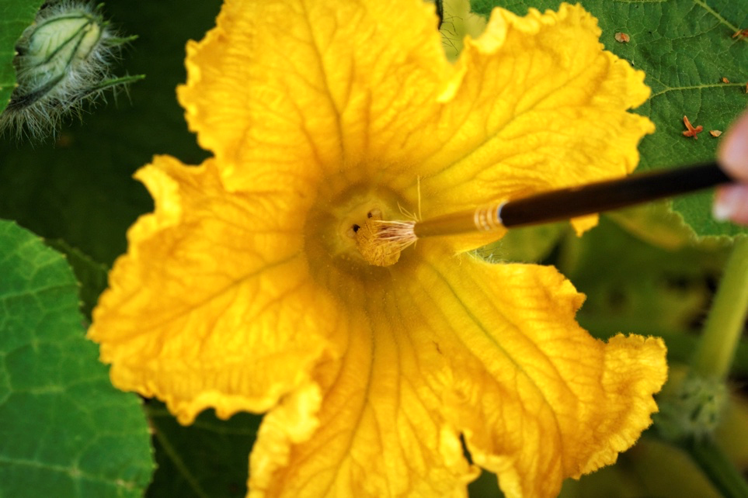

Figure 7.
Hand pollination of a pumpkin flower. When Mendel was doing his crosses with pea plants, he pollinated each flower by hand in a similar way in order to be sure he knew the parents of each cross. (Flickr-S. Hurmerinta- CC BY-NC 2.0

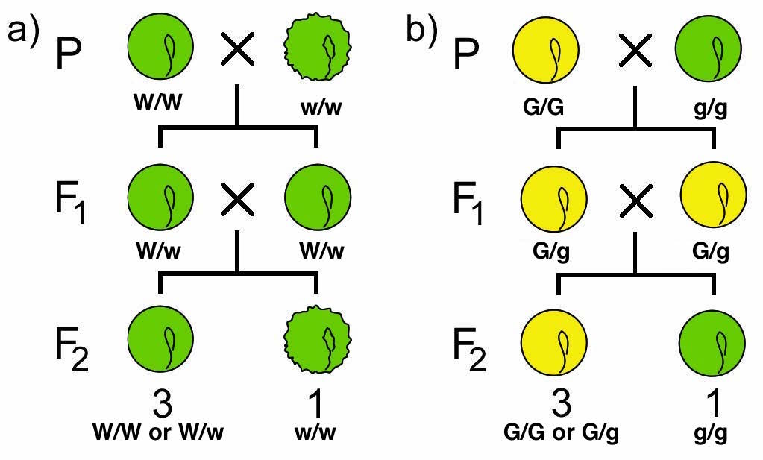

Figure 8
Monohybrid crosses involving two distinct traits in peas. a) is W/w and b) is G/g. Note that seeds in a) also contain a “g” gene that would be homozygous recessive, but this isn’t written out. Seeds in b) are have a “w” gene, but they would be heterozygous or homozygous dominant. By convention, unless a gene is specifically referenced in the problem, we don’t write it down – but it’s still there! (Original-Deyholos-CC BY-NC 3.0-Modified-Nickle)

Figure 9
Independent assortment as seen on two different chromosomes. Gene A is found on the short chromosome and Gene B is found on the long chromosome, and both genes are heterozygotes for the dominant (A and B) and recessive (a and b) alleles. The orientation that the chromosomes align themselves during metaphase I affect the alleles found in the 4 gametes produced after telophase II.
These are just two of many orientations the chromosomes can arrange themselves in at metaphase I. The full stages of meiosis were removed for simplicity; refer to chapter 16 to understand the divisions that lead to the 4 gametes seen in telophase II. (Original-L.Canham-CC BY-NC 3.0)

Chapter 10
Independent assortment as seen on the same chromosome. On the top is an example of what would happen in crossovers did not take place. The dominant alleles of Gene A and Gene D would always travel together, not leading to independent assortment. Crossovers do occur in most situations though, like in the bottom half of the figure. If a crossover occurs between the two genes, then the alleles will transfer to the other non-sister chromatid causing a shuffling of alleles. This allows for independent assortment, despite being on the same chromosome.
This is just one of the many arrangements or crossover events that can occur during meiosis, with every meiocyte arranging themselves differently with different crossovers. (Original-L.Canham-CC BY-NC 3.0)

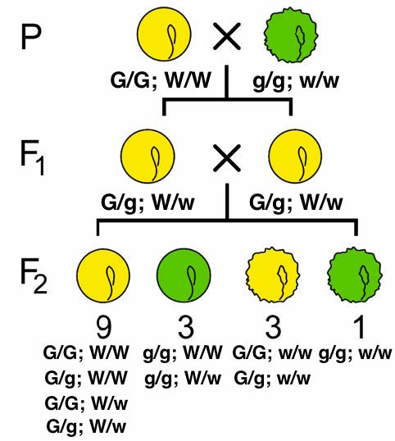
Figure 11
Two pure-breeding lines are crossed to produce dihybrids in the F1 generation. These F1 are crossed to produce four phenotypic classes, which appear in a 9:3:3:1 ratio. (Original-Deyholos-CC BY-NC 3.0 modified by Nickle)

 | W ; G | W ; g | w ; G | w ; g
W ; G | W/W;  G/G | W/W; G/g | W/w; G/G | W/w; G/g
W ; g | W/W; G/g | W/W; g/g | W/w; G/g | W/w; g/g
w ; G | W/w; G/G | W/w; G/g | w/w; G/G | w/w; G/g
w ; g | W/w; G/g | W/w; g/g | w/w; G/g | w/w; g/g

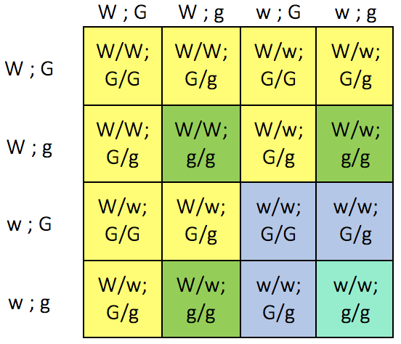
Figure 12
A Punnett Square showing the results of the dihybrid cross from Figure 11. Each of the four phenotypic classes is represented by a different color of shading. (Original-Nickle-CC BY-NC 3.0)

Figure 13
Punnett square for a test cross. The tester in both cases is the male with the genotype r/r ; y/y . On the left, the unknown has a genotype of R/R; Y/Y. On the right, the unknown has the genotype R/R ; Y/y. (Original-L.Canham-CC BY-NC 3.0)

Figure 14
Blank Punnett squares to fill in the other two possibilities of the test cross.

