Chapter 1 Overview, DNA, and Genes
Fig.1-1.
Parent and offspring
Wolf’s Monkey.
(Flickr-eclectic echos-CC:AND)
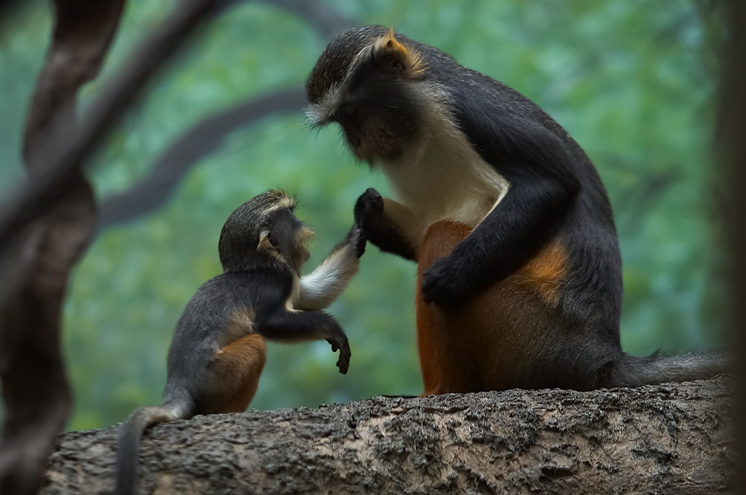

1.1 Overview
Genetics – is the scientific study of heredity and the variation of inherited characteristics. It includes the study of genes, themselves, how they function, interact, and produce the visible and measurable characteristics we see in individuals and populations of species as they change from one generation to the next, over time, and in different environments.
Heredity – Humans have always been aware that the characteristics of an individual plant or animal in a population could be passed down through the generations. Offspring look more like their parents. Humans also knew that some heritable characteristics (such as the size or colour of fruit) varied between individuals, and that they could select or breed crops and animals for the most favorable traits. Knowledge of these hereditary properties has been of significant value in the history of human development. In the past, humans could only manipulate and select from naturally existing combinations of genes. More recently, with the discovery of the substance and nature of genetic material, DNA, we can now identify, clone, and create novel, better combinations of genes that will serve our goals. Understanding the mechanisms of genetics is fundamental to using it wisely and for the betterment of all.

1.2 DNA is the Genetic Material
By the early 1900’s, biochemists had isolated hundreds of different chemicals from living cells. Which of these was the genetic material? Proteins seemed like promising candidates, since they were abundant, diverse, and complex molecules. However, a few key experiments demonstrated that DNA, rather than protein, is the genetic material.

1.2.1 Griffith’s Transformation Experiment (1928)
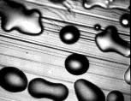
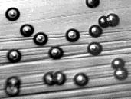
Microbiologists identified two strains of the bacterium Streptococcus pneumoniae. The R-strain produced rough colonies on a bacterial plate, while the other S-strain was smooth (Fig. 1.2). More importantly, the S-strain bacteria caused fatal infections when injected into mice, while the R-strain did not (top, Fig. 1.3). Neither did “heat-treated” S-strain cells. Griffith in 1929 noticed that upon mixing “heat-treated” S-strain cells together with some R-type bacteria (neither should kill the mice), the mice died and there were S-strain, pathogenic cells recoverable. Thus, some non-living component from the S-type strains contained genetic information that could be transferred to and transform the living R-type strain cells into S-type cells.

1.2.2 Avery, MacLeod and McCarty’s Experiment (1944)
Figure 1.2
Colonies of Rough (top) and Smooth (bottom) strains of S. pneumoniae. (J. Exp.Med.98:21, 1953-R. Austrian-Pending)

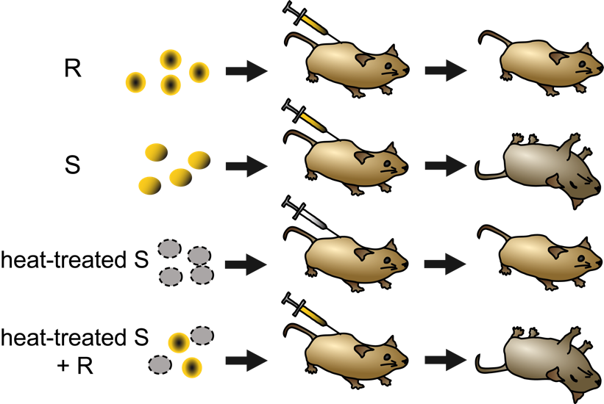
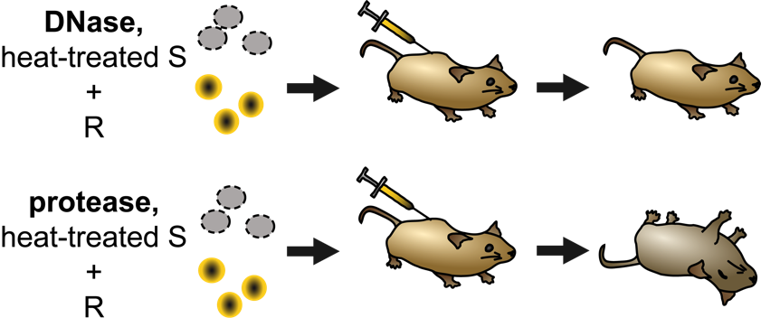
Figure 1.4 Electronmicrograph of T2 bacteriophage on surface of E. coli. (Wikipedia-G. Colm-PD)
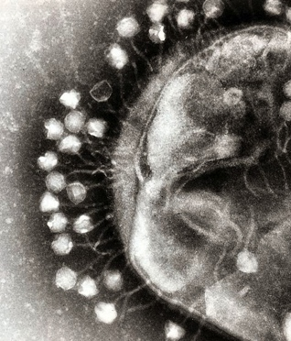
What kind of molecule from within the S-type cells was responsible for the transformation? To answer this, researchers named Avery, MacLeod and McCarty separated the S-type cells into various components, such as proteins, polysaccharides, lipids, and nucleic acids. Only the nucleic acids from S-type cells were able to make the R-strains smooth and fatal. Furthermore, when cellular extracts of S-type cells were treated with DNase (an enzyme that digests DNA), the transformation ability was lost. The researchers therefore concluded that DNA was the genetic material, which in this case controlled the appearance (smooth or rough) and pathogenicity of the bacteria.
Figure 1.3 Experiments of Griffith and of Avery , MacLeod and McCarty.
R strains of S. pneumoniae do not cause lethality. However, DNA-containing extracts from pathogenic S strains are sufficient to make R strains pathogenic. (Original-Deyholos-CC:AN)

1.2.3 Hershey and Chase’s Experiment (1952)
Further evidence that DNA is the genetic material came from experiments conducted by Hershey and Chase. These researchers studied the transmission of genetic information in a virus called the T2 bacteriophage, which used Escherichia coli as its host bacterium (Fig. 1.4). Like all viruses, T2 hijacks the cellular machinery of its host to manufacture more viruses. The T2 phage itself only contains both protein and DNA, but no other class of potential genetic material. To determine which of these two types of molecules contained the genetic blueprint for the virus, Hershey and Chase grew viral cultures in the presence of radioactive isotopes of either phosphorus (³²P) or sulphur (³⁵S). The phage incorporated these isotopes into their DNA and proteins, respectively (Fig 1.5). The researchers then infected E. coli with the radiolabeled viruses, and looked to see whether ³²P or ³⁵S entered the bacteria. After ensuring that all viruses had been removed from the surface of the cells, the researchers observed that infection with ³²P labeled viruses (but not the ³⁵S labeled viruses) resulted in radioactive bacteria. This demonstrated that DNA was the material that contained genetic instructions.
Figure 1.5
When ³²P-labeled phage infects E. coli, radioactivity is found only in the bacteria, after the phage are removed by agitation and centrifugation. In contrast, after infection with ³⁵S-labeled phage, radioactivity is found only in the supernatant that remains after the bacteria are removed. (Original-Deyholos-CC:AN)
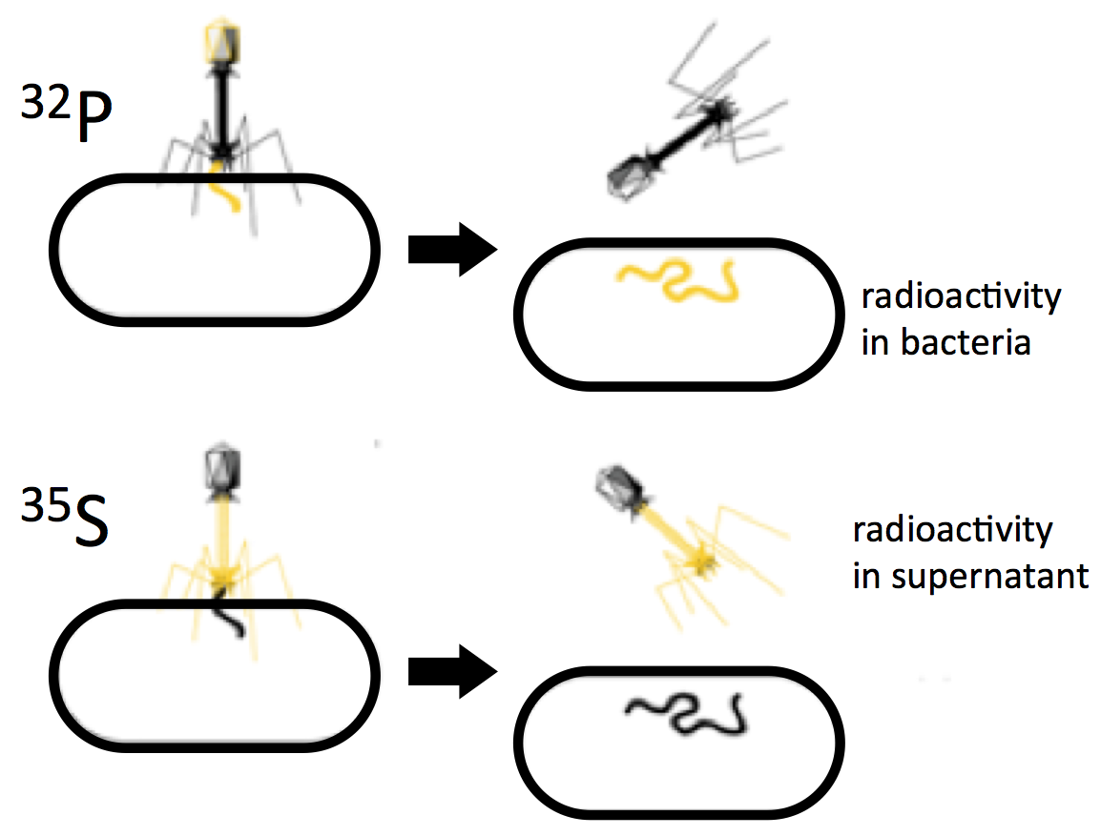

1.2.4 Meselson and Stahl experiment (1958)
From the complementary strands model of DNA, proposed by Watson and Crick in 1953, there were three straightforward possible mechanisms for DNA replication: (1) semi-conservative, (2) conservative, and (3) dispersive (Fig 1.6).
The semi-conservative model proposes the two strands of a DNA molecule separate during replication and then strand acts as a template for synthesis of a new, complementary strand.
The conservative model proposes that the entire DNA duplex acts as a single template for the synthesis of an entirely new duplex.
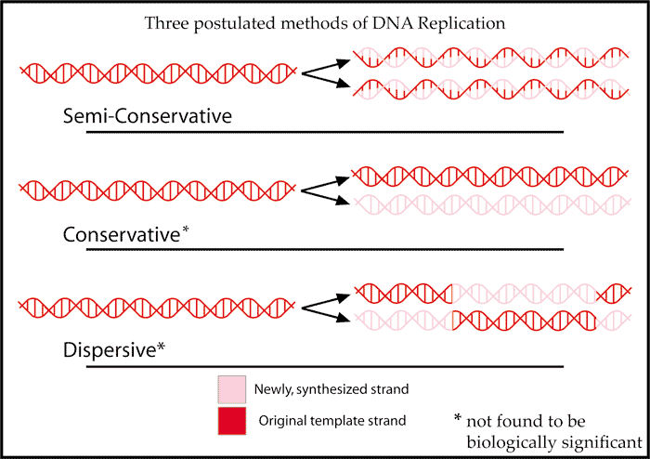
The dispersive model has the two strands of the double helix breaking into units that which are then replicated and reassembled, with the new duplexes containing alternating segments from one strand to the other.
Figure 1.6
The three models of DNA replication possible from the double helix model of DNA structure. (Wikipedia-Adenosine-CC:AN)

Each of these three models makes a different prediction about the how DNA strands should be distributed following two rounds of replication. These predictions can be tested in the following experiment by following the nitrogen component in DNA in E. coli as it goes through several rounds of replication. Meselson and Stahl used different isotopes of Nitrogen, which is a major component in DNA. Nitrogen-14 (¹⁴N) is the most abundant natural isotope, while Nitrogen-15 (¹⁵N) is rare, but also denser. Neither is radioactive; each can be followed by a difference in density – “light” 14 vs “heavy”15 atomic weight in a CsCl density gradient ultra-centrifugation of DNA.
The experiment starts with E. coli grown for several generations on medium containing only ¹⁵N. It will have denser DNA. When extracted and separated in a CsCl density gradient tube, this “heavy” DNA will move to a position nearer the bottom of the tube in the more dense solution of CsCl (left side in Figure 1.7). DNA extracted from E. coli grown on normal, ¹⁴ N containing medium will migrate more towards the less dense top of the tube.
If these E. coli cells are transferred to a medium containing only ¹⁴N, the “light” isotope, and grown for one generation, then their DNA will be composed of one-half ¹⁵N and one-half ¹⁴N. If the this DNA is extracted and applied to a CsCl gradient, the observed result is that one band appears at the point midway between the locations predicted for wholly ¹⁵N DNA and wholly ¹⁴N DNA (Figure 1.7). This “single-band” observation is inconsistent with the predicted outcome from the conservative model of DNA replication (disproves this model), but is consistent with both that expected for the semi-conservative and dispersive models.
If the E. coli is permitted to go through another round of replication in the ¹⁴N medium, and the DNA extracted and separated on a CsCl gradient tube, then two bands were seen by Meselson and Shahl: one at the ¹⁴N-¹⁵N intermediate position and one at the wholly ¹⁴N position (Figure 1.7). This result is inconsistent with the dispersive model (a single band between the ¹⁴N-¹⁵N position and the wholly ¹⁴ N position) and thus disproves this model. The two band observation is consistent with the semi-conservative model which predicts one wholly ¹⁴ N duplex and one ¹⁴N-¹⁵N duplex. Additional rounds of replication also support the semi-conservative model/hypothesis of DNA replication. Thus, the semi-conservative model is the currently accepted mechanism for DNA replication. Note however, that we now also know from more recent experiments that whole chromosomes, which can be millions of bases in length, are also semi-conservatively replicated.
These experiments, published in 1958, are a wonderful example of how science works. Researchers start with three clearly defined models (hypotheses). These models were tested, and two (conservative and dispersive) were found to be inconsistent with the observations and thus disproven. The third hypothesis, semi-conservative, was consistent with the observations and thereby supported and accepted as mechanism of DNA replication. Note, however, this is not “proof” of the model, just strong evidence for it; hypotheses are not “proven”, only disproven or supported. 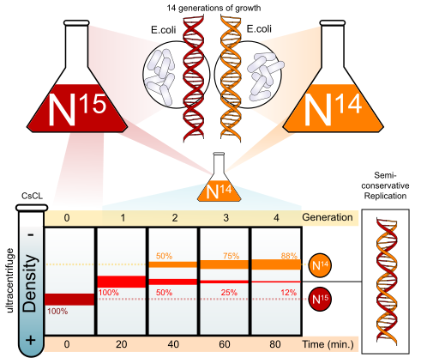
Figure 1.7
The positions of the ¹⁴N and ¹⁵N containing DNA in the density gradient tube on the left. (Wikipedia-LadyofHats-CC:AN)

1.2.5 RNA and protein
While DNA is the genetic material for the vast majority of organisms, there are some viruses that use RNA as their genetic material. These viruses can be either single or double stranded and include SARS, influenza, hepatitis C and polio, as well as the retroviruses like HIV-AIDS. Typically there is DNA used at some stage in their life cycle to replicate their RNA genome.
Also, the case of Prion infections agents transmit characteristics via only a protein (no nucleic acid present). Prions infect by transmitting a misfolded protein state from one aberrant protein molecule to a normally folded molecule. These agents are responsible for bovine spongiform encephalopathy (BSE, also known as "mad cow disease") in cattle and deer and Creutzfeldt–Jakob disease (CJD) in humans. All known prion diseases act by altering the structure of the brain or other neural tissue and all are currently untreatable and ultimately fatal.

1.3 The Structure of DNA
The experiments outlined in the previous sections proved that DNA was the genetic material, but very little was known about its structure at the time.

1.3.1 Chargaff’s Rules
When Watson and Crick set out in the 1940’s to determine the structure of DNA, it was already known that DNA is made up of a series four different types of molecules, called bases or nucleotides: adenine (A), cytosine (C), thymine (T), guanine (G). Watson and Crick also knew of Chargaff’s Rules, which were a set of observations about the relative amount of each nucleotide that was present in almost any extract of DNA. Chargaff had observed that for any given species, the abundance of A was the same as T, and G was the same as C. This was essential to Watson & Crick’s model.

Figure 1.8 Chemical structure of two pairs of nucleotides in a fragment of double-stranded DNA. Sugar, phosphate, and bases A,C,G,T are labeled. Hydrogen bonds between bases on opposite strands are shown by dashed lines. Note that the G-C pair has more hydrogen bonds than A-T. The numbering of carbons within sugars is indicated by red numbers. Based on this numbering the polarity of each strand is indicated by the labels 5’ and 3’. (Wikipedia-M. Strock-GFDL)
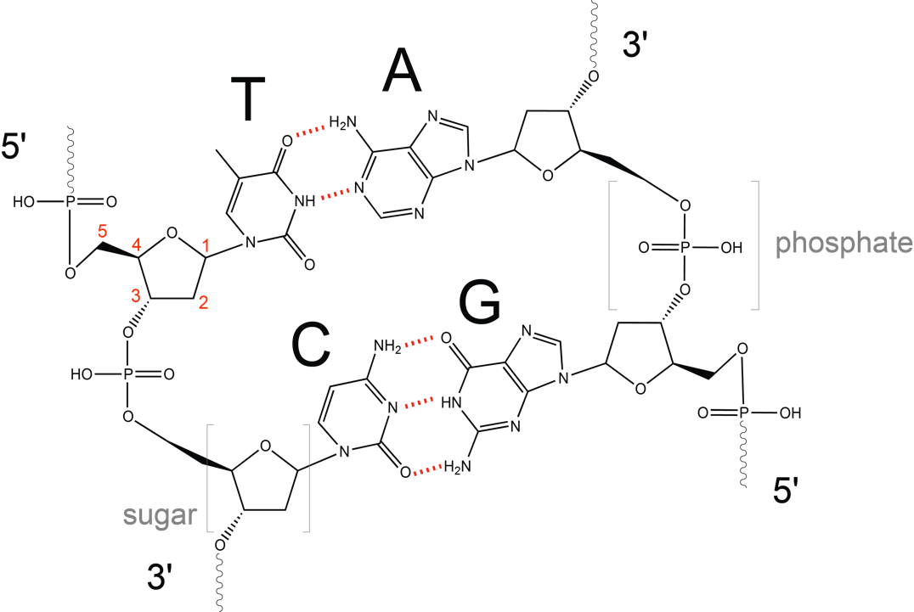

1.3.2 The Double Helix
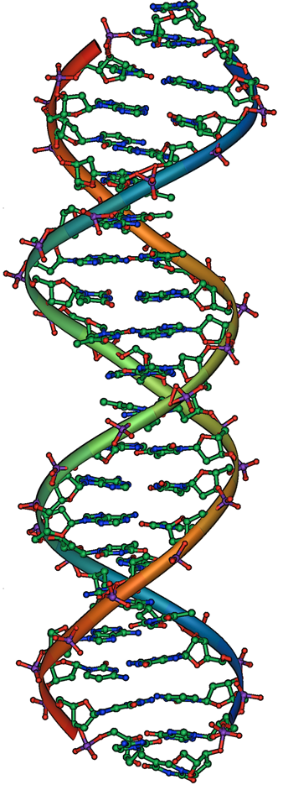
Figure 1.9
DNA double helix structure. (Original-unknown-?)
Using proportional metal models of the individual nucleotides, Watson and Crick deduced a structure for DNA that was consistent with Chargaff’s Rules and with x-ray crystallography data that was obtained (with some controversy) from another researcher named Rosalind Franklin. In Watson and Crick’s famous double helix, each of the two strands contains DNA bases connected through covalent bonds to a sugar-phosphate backbone (Fig 1.8, 1.9). Because one side of each sugar molecule is always connected to the opposite side of the next sugar molecule, each strand of DNA has polarity: these are called the 5’ (5-prime) end and the 3’ (3-prime) end, in accordance with the nomenclature of the carbons in the sugars. The two strands of the double helix run in anti-parallel (i.e. opposite) directions, with the 5’ end of one strand adjacent to the 3’ end of the other strand. The double helix has a right-handed twist, (rather than the left-handed twist that is often represented incorrectly in popular media). The DNA bases extend from the backbone towards the center of the helix, with a pair of bases from each strand forming hydrogen bonds that help to hold the two strands together. Under most conditions, the two strands are slightly offset, which creates a major groove on one face of the double helix, and a minor groove on the other. Because of the structure of the bases, A can only form hydrogen bonds with T, and G can only form hydrogen bonds with C (remember Chargaff’s Rules). Each strand is therefore said to be complementary to the other, and so each strand also contains enough information to act as a template for the synthesis of the other. This complementary redundancy is important in DNA replication and repair.
How can this molecule, DNA, contain the genetic material?

1.4 Genes are the Basic Units of Inheritance

1.4.1 Blending vs Particulate inheritance
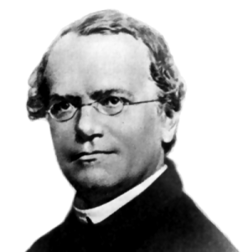
Figure 1.10
Gregor Mendel. (Original-unknown-PD)
The once prevalent (but now discredited) concept of blending inheritance proposed that some undefined essence, in its entirety, contained all of the heritable information for an individual. It was thought that mating combined the essences from each parent, much like the mixing of two colors of paint. Once blended together, the individual characteristics of the parents could not be separated again. However, Gregor Mendel (Fig 1.10) was one of the first to take a quantitative, scientific approach to the study of heredity. He started with well-characterized strains, repeated his experiments many times, and kept careful records of his observations. Working with peas, Mendel showed that white-flowered plants could be produced by crossing two purple-flowered plants, but only if the purple-flowered plants themselves had at least one white-flowered parent (Fig 1.11). This was evidence that the genetic factor that produced white-flowers had not blended irreversibly with the factor for purple-flowers. Mendel’s observations disprove blending inheritance and favor an alternative concept, called particulate inheritance, in which heredity is the product of discrete factors that control independent traits.

Figure 1.11
Inheritance of flower color in peas. Mendel observed that a cross between pure breeding, white and purple peas (generation P) produced only progeny (generation F₁) with purple flowers. However, white flowered plant reappeared among the F₂ generation progeny of a mating between two F₁ plants. The symbols P, F₁ and F₂ are abbreviations for parental, first filial, and second filial generations, respectively.
(Original-Deyholos-CC:AN)

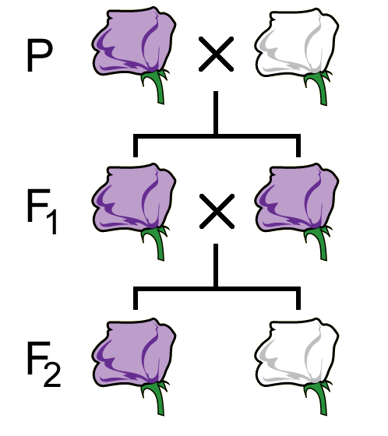

1.4.2 Genes and alleles
Mendel’s discrete “factors of heredity” later became known as genes. Each hereditary factor could exist in one or more different versions or forms, which we now call alleles. In its narrowest definition, a gene is an abstract concept: a unit of inheritance. The connection between genes and substances like DNA and chromosomes was established largely through the experiments described in the remainder of this chapter. However, it is worth noting that Mendel and many researchers who followed him were able to provide great insights into biology, simply by observing the inheritance of specific traits – genetics.

1.5 The Function of Genes

1.5.1 Beadle and Tatum: one gene, one enzyme hypothesis
Life depends on (bio)chemistry to supply energy and to produce the molecules to construct and regulate cells. In 1908, A. Garrod described “in born errors of metabolism” in humans using the congenital disorder, alkaptonuria (black urine disease), as an example of how “genetic defects” led to the lack of an enzyme in a biochemical pathway and caused a disease (phenotype). Over 40 years later, in 1941, Beadle and Tatum built on this connection between genes and metabolic pathways. Their research led to the “one gene, one enzyme (or protein)” hypothesis, which states that each of the enzymes that act in a biochemical pathway is encoded by a different gene. Although we now know of many exceptions to the “one gene, one enzyme (or protein)” principle, it is generally true that each different gene produces a protein that has a distinct catalytic, regulatory, or structural function.
Figure 1.12
A single mutagenized spore is used to establish a colony of genetically identical fungi, from which spores are tested for their ability to grow on different types of media. Because spores of this particular colony are able to grown only on complete medium (CM), or on miminal medium supplemented with arginine (MM+Arg), they are considered Arg auxotrophs and we infer that they have a mutation in a gene in the Arg biosynthetic pathway. This type of screen is repeated many times to identify other mutants in the Arg pathway and in other pathways.
(Original-Deyholos-CC:AN)
Beadle and Tatum used the fungus Neurospora crassa (a mold) for their studies because it had practical advantages as a laboratory organism. They knew that Neurospora was prototrophic, meaning that it could synthesize its own amino acids when grown on minimal medium, which lacked most nutrients except for a few minerals, simple sugars, and one vitamin (biotin). They also knew that by exposing Neurospora spores to X-rays, they could randomly damage its DNA to create mutations in genes. Each different spore exposed to X-rays potentially contained a mutation in a different gene. After genetically screening many, many spores for growth, most appeared to still be prototrophic and still able to grow on minimal medium. However, some spores had mutations that changed them into auxotrophic strains that could no longer grow on minimal medium, but did grow on complete medium supplemented with nutrients (Fig. 1.12). In fact, some auxotrophic mutations could grow on minimal medium with only one, single nutrient supplied, such as arginine.

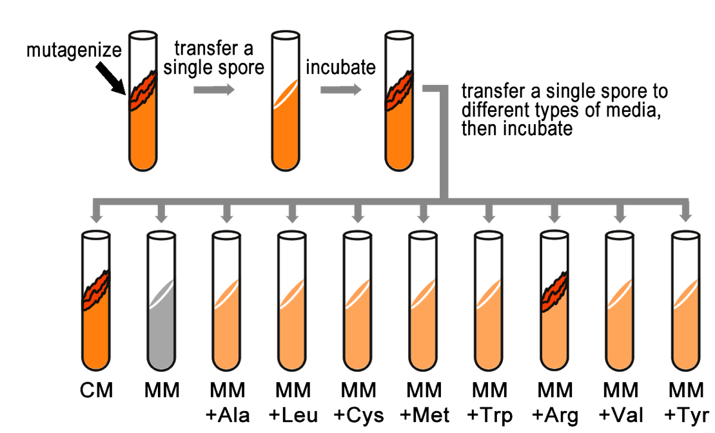
1.5.2 B&T’s 1 gene: 1 enzyme hypothesis led to Biochemical Pathway dissection using genetic screens and mutations
Beadle and Tatum’s experiments are important not only for its conceptual advances in understanding genes, but also because they demonstrate the utility of screening for genetic mutants to investigate a biological process – genetic analysis.
Beadle and Tatum’s results were useful to investigate biological processes, specifically the metabolic pathways that produce amino acids. For example, Srb and Horowitz in 1944 tested the ability of the amino acids to rescue auxotrophic strains. They added one of each of the amino acids to minimal medium and recorded which of these restored growth to independent mutants.

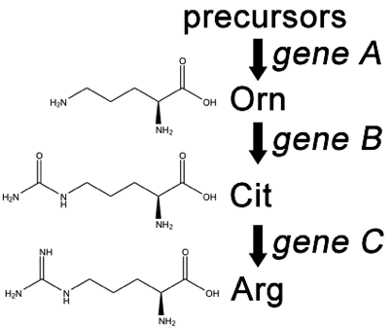
For example, if the progeny of a mutagenized spore could grow on minimal medium only when it was supplemented with arginine (Arg), then the auxotroph must bear a mutation in the Arg biosynthetic pathway and was called an “arginineless” strain (arg-).
Figure 1.13
A simplified version of the Arg biosynthetic pathway, showing citrulline (Cit) and ornithine (Orn) as intermediates in Arg metabolism. These chemical reactions depend on enzymes represented here as the products of three different genes. (Original-Deyholos-CC:AN)
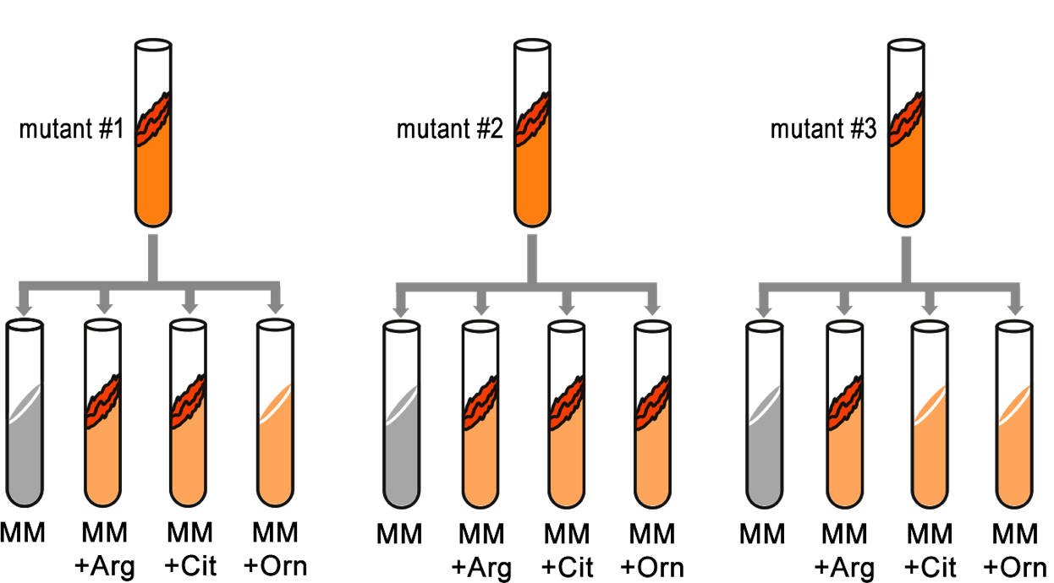
Synthesis of even a relatively simple molecule such as arginine requires many steps, each with a different enzyme. Each enzyme works sequentially on a different intermediate in the pathway (Fig. 1.13). For arginine (Arg), two of the intermediates are ornithine (Orn) and citrulline (Cit). Thus, mutation of any one of the enzymes in this pathway could turn Neurospora into an Arg auxotroph (arg-). Srb and Horowitz extended their analysis of Arg auxotrophs by testing the intermediates of amino acid biosynthesis for the ability to restore growth of the mutants (Figure 1.14).
Figure 1.14
Testing different Arg auxotrophs for their ability to grow on media supplemented with intermediates in the Arg biosynthetic pathway. (Original-Deyholos-CC:AN)

They found that some of the Arg auxotrophs could be rescued only by Arg, while others could be rescued by either Arg or Cit, and still other mutants could be rescued by Arg, Cit, or Orn (Table 1.1). Based on these results, they deduced the location of each mutation in the Arg biochemical pathway, (i.e. which gene was responsible for the metabolism of which intermediate).

1.5.3 Genetic screens for mutations help characterize biological pathways
Using many other mutations and the “one gene: one enzyme model” permitted the genetic dissection of many other biochemical and developmental pathways.
The general strategy for a genetic screen for mutations is to expose a population to a mutagen, then look for individuals among the progeny that have defects in the biological process of interest. There are many details that must be considered when designing a genetic screen (e.g. how can recessive alleles be made homozygous). Nevertheless, mutational analysis has been an extremely powerful and efficient tool in identifying and characterizing the genes involved in a wide variety of biological processes, including many genetic diseases in humans.
 | MM + Orn | MM + Cit | MM + Arg
gene A mutants | Yes | Yes | Yes
gene B mutants | No | Yes | Yes
gene C mutants | No | No | Yes
Table 1.1 Ability of auxotrophic mutants of each of the three enzymes of the Arg biosynthetic pathways to grow on minimal medium (MM) supplemented with Arg or either of its precursors, Orn and Cit. Gene names refer to the labels used in Figure 1.11

1.5.4 The Central Dogma
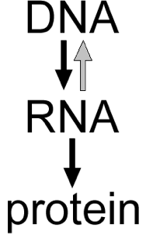
Figure 1.15
Central Dogma of molecular biology. (Original-Deyholos-CC:AN)
How does the structure of DNA and genes relate to inheritance of biological traits such as the flower color of Mendel’s peas? The answer lies in what has become known as molecular biology’s Central Dogma (Fig 1.15), which has come to be described as the genetic information of each gene is encoded in DNA, and then, as needed, this information is transcribed into an RNA sequence, and then translated into a polypeptide (protein) sequence. The core of the Central Dogma is that genetic information is NEVER transferred from protein back to nucleic acids. In certain circumstances, the information in RNA may also be converted back to DNA through a process called reverse transcription. As well, DNA, and its information, can also be replicated (DNA➔DNA). The sequence of bases in DNA directly dictates the sequence of bases in the RNA, which in turn dictates the sequence of amino acids that make up a polypeptide. Proteins do most of the work in a cell. They (1) catalyze the formation and breakdown of most molecules within an organism as well as (2) form their structural components and (3) regulate the expression of genes. By dictating the structure of each protein, DNA affects the function of that protein, which can thereby affect the entire organism. Thus the genetic information, or genotype, defines the potential form, or phenotype of the organism.
In the case of Mendel’s peas, purple-flowered plants have a gene that encodes an enzyme that produces a purple pigment molecule. In the white-flowered plants (a purple-less mutant), the DNA for this gene has been changed, or mutated, so that it no longer encodes a functional protein. This is an example of a spontaneous, natural mutation in a biochemical pathway.

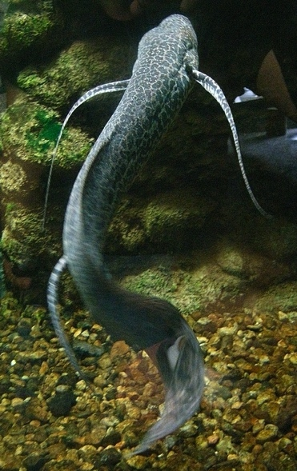
1.6 The Nuclear Genome

1.6.1 The C-value of the nuclear genome
Table 1.2
Measures of genome size in selected organisms. The DNA content (1C) is shown in millions of basepairs (Mb). For eukaryotes, the chromosome number is the chromosomes counted in a gamete (1N) from each organism. The average gene density is the mean number of non-coding bases (in bp) between genes in the genome."

 | DNA content (Mb, 1C) | Estimated gene number | Average gene density | Chromosome number (1N)
Homo sapiens | 3,200 | 25,000 | 100,000 | 23
Mus musculus | 2,600 | 25,000 | 100,000 | 20
Drosophila melanogaster | 140 | 13,000 | 9,000 | 4
Arabidopsis thaliana | 130 | 25,000 | 4,000 | 5
Caenorhabditis elegans | 100 | 19,000 | 5,000 | 6
Saccharomyces cerevisiae | 12 | 6,000 | 2,000 | 16
Escherichia coli | 5 | 3,200 | 1,400 | 1
The complete set of DNA within the nucleus of any organism is called its nuclear genome and is measured as the C-value in units of either the number of base pairs or picograms of DNA. There is a general correlation between the nuclear DNA content of a genome (i.e. the C-value) and the physical size or complexity of an organism. Compare the size of E. coli and humans for example in the table below. There are, however, many exceptions to this generalization, such as the human genome contains only 3.2 x 10⁹ DNA bases, while the wheat genome contains 17 x 10⁹ DNA bases, almost 6 times as much. The Marbled Lungfish (Protopterus aethiopicus – Fig. 1.16) contains ~133 x 10⁹ DNA bases, (~45 times as much as a human) and a fresh water amoeboid, Polychaos dubium, which has as much as 670 x 10⁹ bases (200x a human).
Fig 1.16
Marbled Lungfish. (Wikipedia-OpenCage-CC:AS)

1.6.2 The C-value paradox
This apparent paradox (called the C-value paradox) can be explained by the fact that not all nuclear DNA encodes genes – much of the DNA in larger genomes is non-gene coding. In fact, in many organisms, genes are separated from each other by long stretches of DNA that do not code for genes or any other genetic information. Much of this “non-gene” DNA consists of transposable elements of various types, which are an interesting class of self-replicating DNA elements discussed in more detail in a subsequent chapter. Other non-gene DNA includes short, highly repetitive sequences of various types.

1.6.3 Other genomes
Organelles such as mitochondria and chloroplasts also have their own genomes. These are, compared to the nuclear genome, relatively small and are also circular, like the prokaryotes from which they originated (Endosymbiont hypothesis).

1.7 Model Organisms Facilitate Genetic Advances

1.7.1 Model organisms
Many of the great advances in genetics were made using species that are not especially important from a medical, economic, or even ecological perspective. Geneticists, from Mendel onwards, have sought the best organisms for their experiments. Today, a small number of species are widely used as model organisms in genetics (Fig 1.17). All of these species have specific characteristics that make large number of them easy to grow and analyze in laboratories: (1) they are small, (2) fast growing with a short generation time, (3) produce lots of progeny from matings that can be easily controlled, (4) have small genomes (small C-value), and (5) are diploid (i.e. chromosomes are present in pairs).
The most commonly used model organism are:
- The prokaryote bacterium, Escherichia coli, is the simplest genetic model organism and is often used to clone DNA sequences from other model species.
- Yeast (Saccharomyces cerevisiae) is a good general model for the basic functions of eukaryotic cells.
- The roundworm, Caenorhabditis elegans is a useful model for the development of multicellular organisms, in part because it is transparent throughout its life cycle, and its cells undergo a well-characterized series of divisions to produce the adult body.
- The fruit fly (Drosophila melanogaster) has been studied longer, and probably in more detail, than any of the other genetic model organisms still in use, and is a useful model for studying development as well as physiology and even behaviour.
- The mouse (Mus musculus) is the model organism most closely related to humans, however there are some practical difficulties working with mice, such as cost, slow reproductive time, and ethical considerations.
- The zebrafish (Danio rerio) has more recently been developed by researchers as a genetic model for vertebrates. Unlike mice, zebrafish embryos develop quickly and externally to their mothers, and are transparent, making it easier to study the development of internal structures and organs.
- Finally, a small weed, Arabidopsis thaliana, is the most widely studied plant genetic model organism. This provides knowledge that can be applied to other plant species, such as wheat, rice, and corn.

1.7.2 Society benefits from model organism research
The study of genetic model organisms has greatly increased our knowledge of genetics, and biology in general. Knowledge from model organisms has also provided important implications in medical research, agriculture, and biotechnology. By using these species genetic researchers can discover more knowledge, faster and cheaper than using humans, farm animals or crop plants directly. For example, at least 75% of the approximately 1,000 genes that have been associated with specific human diseases have similar genes in D. melanogaster. Information about how these genes function in model organisms can usually be applied to other species, including humans. From research conducted thus far, we have learned that the main features of many biochemical, cellular, and developmental pathways tend to be common among all species. What is genetically and biochemically true in yeast, worms, flies and mice tends to be true in humans, too.
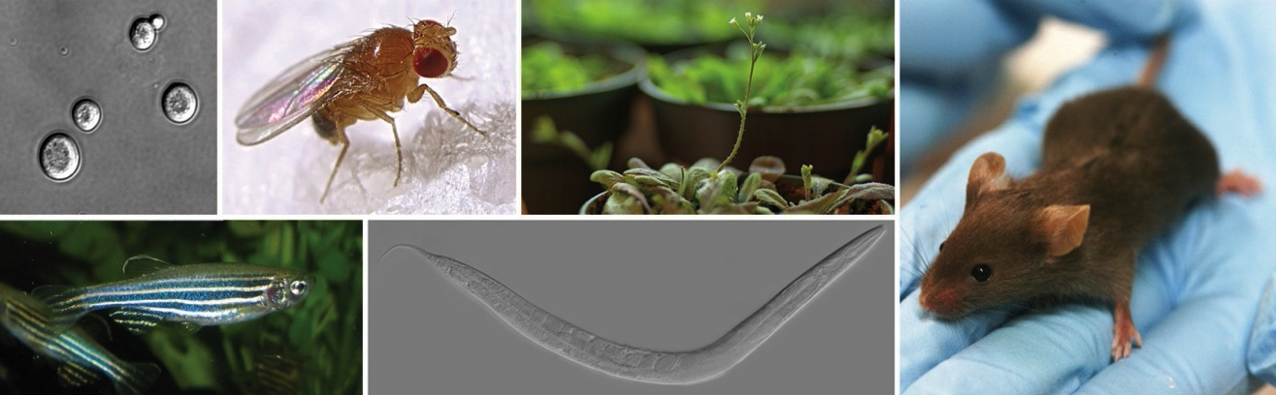
However, it is sometimes necessary to study important biological processes in non-model organisms. In humans, for example, there are some diseases or other traits for which no clear analog exists in model organisms. In these cases the tools of genetic analysis developed in model organisms can be applied to these other, non-model species. Examples include the development of new types of gene discovery techniques, genetic mapping of desired traits, and whole genome sequencing.
Figure 1.17
Some of the most important genetic model organisms in use today. Clockwise from top left: yeast, fruit fly, arabidopsis, mouse, roundworm, zebrafish.
(Original/Flickr/Wikipedia – Deyholos/M.Westby/D.Joly/Z.F.Altun/Masur/Azul – CC:AS/ANS/AN &GFDL )
____________________________________________________________

Summary
- Mendel demonstrated that heredity involved discrete, heritable factors that affected specific traits.
- A gene can be defined abstractly as a unit of inheritance.
- The ability of DNA from bacteria and viruses to transfer genetic information into bacteria demonstrated that DNA is the genetic material.
- DNA is a double helix made of two anti-parallel strands of bases on a sugar-phosphate backbone.
- Specific bases on opposite strands pair through hydrogen bonding, ensuring complementarity of the strands.
- The Central Dogma explains how DNA dictates heritable traits.
- Not all DNA in an organism contains genes.
- Model organisms accelerate the use of genetics in basic and applied research in biology, agriculture and medicine.

Key Terms

blending inheritance
particulate inheritance
Mendel
gene
allele
trait
P, F1, F2
Griffith
Avery, MacLeod, & McCarty
Hershey and Chase
Meselson & Stahl
DNase
proteinase
³⁵S
³²P
bacteriophage
semi-conservative
conservative
dispersive
E. coli
Nitrogen-14
Nitrogen-15
heavy vs light
CsCl gradient

Beadle & Tatum
auxotroph
prototroph
metabolic pathway
Neurospora crassa
Chargaff’s Rules
Watson and Crick
DNA bases
sugar-phosphate backbone
anti-parallel
complementary
hydrogen bond
minor groove
major groove
adenine
cytosine
thymine
guanine
Central Dogma
transcription
reverse transcription
translation
RNA
prion
one-gene:one-enzyme
minimal medium
complete medium
arginine
genetic screen
nuclear genome
c-value paradox
model organism
Saccharomyces cerevisiae
Caenorhabditis elegans
Drosophila melanogaster
Mus musculus
Danio rerio
Arabidopsis thaliana
Escherichia coli

______________________________________________

Study Questions

1.1 How would the results of the cross in Figure 1.11 have been different if heredity worked through blending inheritance rather than particulate inheritance?

1.2 Imagine that astronauts provide you with living samples of multicellular organisms discovered on another planet. These organisms reproduce with a short generation time, but nothing else is known about their genetics.
a) How could you define laws of heredity for these organisms?
b) How could you determine what molecules within these organisms contained genetic information?
c) Would the mechanisms of genetic inheritance likely be similar for all organisms from this planet?
d) Would the mechanisms of genetic inheritance likely be similar to organisms from earth?

1.3 It is relatively easy to extract DNA and protein from cells; biochemists had been doing this since at least the 1800’s. Why then did Hershey and Chase need to use radioactivity to label DNA and proteins in their experiments?

1.4 Compare Watson and Crick’s discovery with Avery, MacLeod and McCarty’s discovery.
a) What did each discover, and what was the impact of these discoveries on biology?
b) How did Watson and Crick’s approach generally differ from Avery, MacLeod and McCarty’s?
c) Briefly research Rosalind Franklin on the internet. Why is her contribution to the structure of DNA controversial?

1.5 Starting with mice and R and S strains of S. pneumoniae, what experiments in additional to those shown in Figure 1.3 to demonstrate that DNA is the genetic material?

1.6 List the information that Watson and Crick used to deduce the structure of DNA.

1.7 Refer to Watson and Crick’
a) List the defining characteristics of the structure of a DNA molecule.
b) Which of these characteristics are most important to replication?
c) Which characteristics are most important to the Central Dogma?

1.8 Compare Figure 1.13 and Table 1.1. Which of the mutants (#1, #2, #3) shown in Figure 1.13 matches each of the phenotypes expected for mutations in genes A, B,C?

1.9 Refer to Table 1.2
a) What is the relationship between DNA content of a genome, number of genes, gene density, and chromosome number?
b) What feature of genomes explains the c-value paradox?
c) Do any of the numbers in Table 1.2 show a correlation with organismal complexity?

1.10 a) List the characteristics of an ideal model organism.
b) Which model organism can be used most efficiently to identify genes related to:

i) eye development
ii) skeletal development
iii) photosynthesis
iii) cell division
iv) cell differentiation
v) cancer

1.11 Refer to Figure 1.8
a) Identify the part of the DNA molecule that would be radioactively labeled in the manner used by Hershey & Chase
b) DNA helices that are rich in G-C base pairs are harder to separate (e.g. by heating) than A-T rich helices. Why?

Notes:

Chapter 1 - Answers

1.1 If genetic factors blended together like paint then they could not be separated again. The white flowered phenotype would therefore not reappear in the F₂ generation, and all the flowers would be purple or maybe light purple.
1.2 a) Identify pure breeding lines of the individuals that differed in some detectable trait, then cross the lines with the different traits and see how the traits were inherited over several generations.
b) Purify different biochemical components, then see if any of the components were sufficient to transfer traits from one individual to another.
c) It depends in part whether the organisms all evolved from the same ancestor. If so, then it seems likely.
d) The extraterrestrials would not necessarily (and perhaps would be unlikely) to have the same types of reductional divisions of chromosome-like material prior to sexual reproduction. In other words, there are many conceivable ways to accomplish what sex, meiosis, and chromosomes accomplish on earth.
1.3 Hershey and Chase wanted to be able to track DNA and protein molecules from a specific source, within a mixture of other protein and DNA molecules. Radioactivity is a good way to label molecules, since detection is quite sensitive and the labeling does not interfere with biological function.
1.4 a) Avery and colleagues demonstrated that DNA was likely the genetic material, while Watson and Crick demonstrated the structure of the molecule. By knowing the structure, it was possible to understand how DNA replicated, and how it encoded proteins, etc.
b) Avery and colleagues performed experiments, while Watson and Crick mostly analyzed the data of others and used that to build models.
c) Watson and Crick relied on Franklin’s data in building their model. It is controversial whether Watson and Crick should have been given access to these data.
1.5 The experiments shown in Figure 1.3 show that DNA is necessary for transformation, (since removing the DNA by nuclease treatment removes the competency for transformation). However, this does not demonstrate that DNA is sufficient to transfer genetic information; you could therefore try to purify S strain DNA and see if injecting that DNA alone could transform R strains into S strains.
1.6 Chargaff’s Rules, X-ray crystallography data, and Avery, MacLeod & McCarty and Hershey & Chase’s data, as well as other information (e.g. specific details about the structure of the bases).
1.7 a) Right-handed, anti-parallel double helix with a major and minor groove. Each strand is composed of sugar-nucleotide bases linked together by covalent phosphodiester bonds. Specific bases on opposite strands of the helix pair together through hydrogen bonding, so that each strand contains the same information in a complementary structure.
b) The complimentarity of the bases and the redundant nature of the strands.
c) The order of the bases.
1.8 Mutant strain #1 has a mutation in gene B (but genes A and C are functional).
Mutant strain #2 has a mutation in gene A (but genes B and C are functional).
Mutant strain #3 has a mutation in gene C (but genes A and B are functional).
1.9 a) There is little correlation between any of these.
b) Genomes have different amounts of non-coding DNA between genes.
c) No.
1.10 a) Fast and simple to grow in high density, diploid,
b) i) zebrafish (for vertebrate eyes); flies for eyes in general
ii) zebrafish
iii) Arabidopsis
iii) yeast
iv) C. elegans
v) arguably, any of the organisms, but the vertebrates would be most relevant
1.11 a) Hershey & Chase labeled the phosphate groups that join the bases
b) G-C pairs have more hydrogen bonds, so more energy is required to break the larger number of bonds in a G-C rich region as compared to an A-T rich region.

