Chapter 9
Changes in Chromosome Number & Structure
Figure 9.1
Fluorescence in situ hybridization of mitotic chromosomes from a human cancer cell.
(Wikipedia-Pmx-CC:AS)
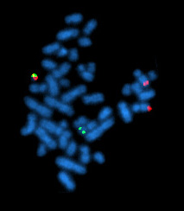
Previous chapters described chromosomes as simple linear DNA molecules on which genes are located. For example, your largest chromosome, chromosome 1, has about 3536 genes. To ensure that each of your cells possesses these genes the chromosome has features that allow it to be passed on during cell division. Origins of replication found along its length provide places for DNA replication to start, telomeres protect each end of the chromosome, and a single centromere near the middle provides a place for microtubules to attach and move the chromosome during mitosis and meiosis.
This chapter examines (1) changes in the number of whole chromosomes and how they affect the phenotype of an organism and (2) changes in the structure of individual chromosomes and how they affect meiotic pairing. Human examples will be used to show the phenotypic consequences and methods for detection.

9.1 Changes in Chromosome Number
If something goes wrong during cell division, an entire chromosome may be lost and the cell will lack all of these genes. The causes behind these chromosome abnormalites and the consequences they have for the cell and the organism is the subject of this section.

9.1.1 Cause: Nondisjunction During Mitosis or Meiosis
Segregation occurs in anaphase. In mitosis and meiosis II, sister chromatids (of replicated chromosomes) are normally pulled to opposite ends of the cell (see Figure 2.12). In Meiosis I, it is homologous chromosomes, which are synapsed at that time, that segregate and move apart.
In rare cases, the sister chromatids (or paired chromosomes in Meiosis I) fail to separate, or dis-join. This failure to segregate properly is called nondisjunction and it can happen during mitosis, meiosis I, or meiosis II. This nondisjunction results in both chromatids (or chromosomes) moving to one pole and none at the other. One cell will have an extra copy and the other will lack a copy. Thus failure to segregate properly leads to unbalanced products.
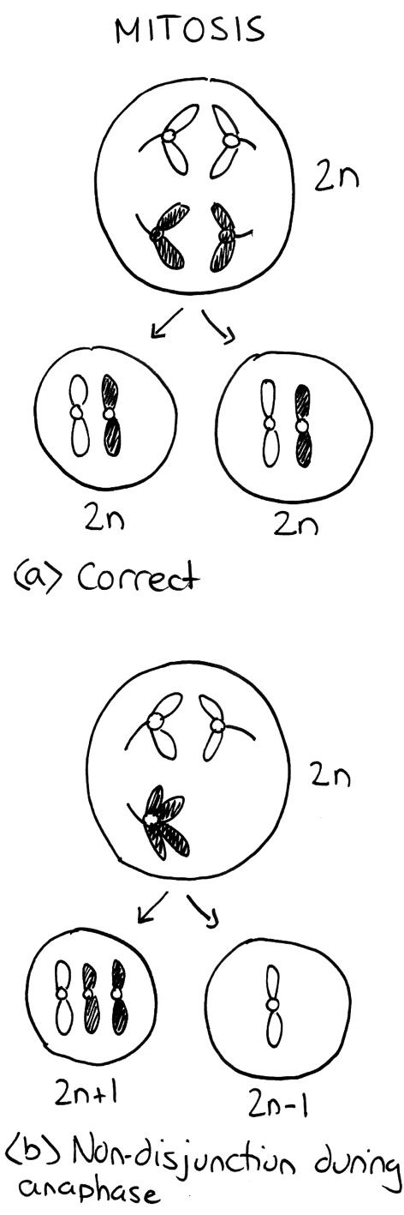  Figure 9.2  Mitosis done successfully (a) and unsuccessfully (b). The cell is diploid and the homologs of one chromosome are shown in white and black. (Original-Harrington-CC:AN)  Figure 9.3  Meiosis done successfully (a) and unsuccessfully (b and c). (Original-Harrington-CC:AN) | 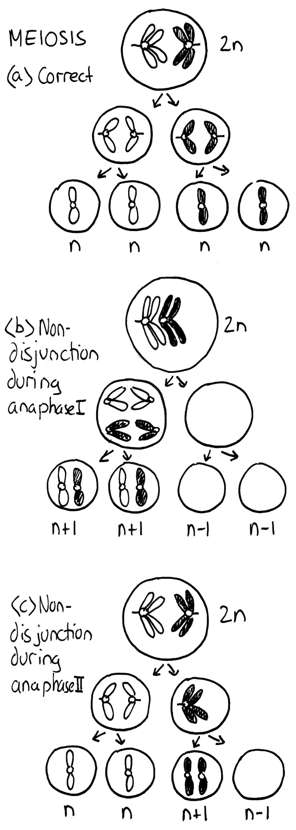

9.1.2 Consequence: Decreased Viability
The result of a non-disjunction event is daughter cells that have an abnormal number of chromosomes. Cells, such as the parent cell in Figure 9.2a, which have the proper number of chromosomes, are said to be euploid. The daughter cells have one too many or one too few chromosomes and are thus aneuploid. Even though both product cells have at least one copy of all genes, both cells will probably die. The reason is due to the loss or gain of a large number of genes. Genes produce an standard amount of product - either functional RNAs or proteins. The parent cell shown has a balanced genotype because it has two copies of all of its genes. Each of its genes produces half of the products needed by the cell. But if one of these cells suddenly had only one copy (or three copies) of an important gene, the amount of product would be either 50% (or 150%) of what was required. Such a change for a single gene could probably be tolerated by the cell and it would probably survive. But the sudden change to one copy (or three copies) of the hundreds or thousands of genes on an entire chromosome the results would be more than tolerable and be catastrophic for the daughter cells. They have what’s called an unbalanced genotype, which usually decreases their viability.
If a first division or second division nondisjunction event occurs during meiosis the result is an unbalanced gamete (Figure 9.3b and c). The gamete will often be functional, but after fertilization the embryo will be genetically unbalanced. This usually leads to the death of the embryo. There are some exceptions to this in humans and these will be presented later in this chapter.

9.2 Changes in Chromosome Structure
If the chromosome is altered, but still retains the three critical features of a chromosome (centromeres, telomeres, and origin of replication), it will continue to be inherited during subsequent cell divisions, however the daughter cell may not retain all the genes. For example, if a segment of the chromosome has been lost, the cell may be missing some genes. The causes of chromosome structural abnormalites and the consequences they have for the cell and the organism is shown below. They all involve breaks in the DNA that makes up the chromosome.

9.2.1 Cause #1: Incorrect Repair of Double Strand DNA Breaks During Interphase
A chromosome is a very long but very thin molecule. In the phopho-diester backbone there are only two covalent bonds holding each base pair to the next. If one of these covalent bonds is broken the chromosome will still remain intact, although a DNA Ligase will be needed to repair the nick (Figure 9.4a). Problems arise when both strands are broken at or near the same location. This double strand break will cleave the chromosome into two independent pieces (Figure 9.4b). Because these events do occur in cells there is a repair system called the non-homologous end joining (NHEJ) system to fix them. Proteins bind to each broken end of the DNA and reattach them with new covalent bonds. This system is not perfect and sometimes leads to chromosome rearrangements (see next section).

The NHEJ system proteins only function if required. If the chromosomes within an interphase nucleus are all intact the system is not active. The telomeres at the natural ends of chromosomes prevent the NHEJ system from attempting to join the normal ends of chromosomes together. If there is one double strand break the two broken ends can be recognized and joined. But if there are two double strand breaks at the same time there will be four broken ends in total. The NHEJ system proteins may join the ends together correctly but if they do not the result is a chromosome rearrangement (Figure 9.5).

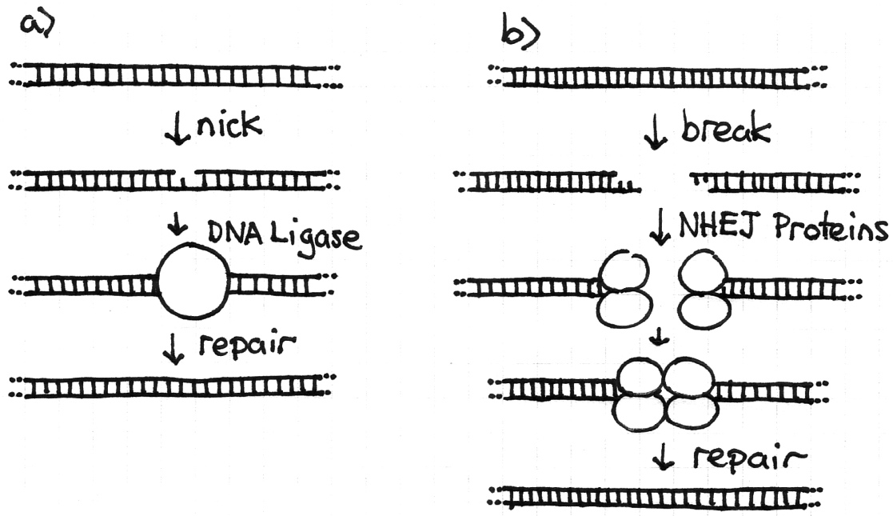 | Figure 9.4 Repair of single strand nicks and double strand breaks in DNA. (Original-Harrington-CC:AN)

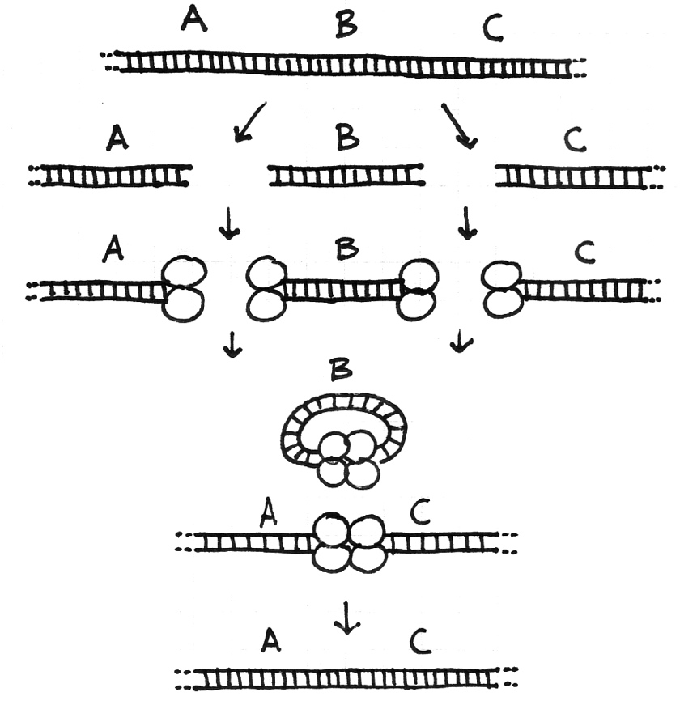 | Figure 9.5 Errors during DNA repair can cause a chromosome deletion. In this diagram A, B, and C are genes on the same chromosome. As in Figure 9.4 there has been breaks in the DNA, recruitment of NHEJ proteins, and repair. After the repairs are completed the small piece of DNA with gene B is lost and the chromosome now only has genes A and C. (Original-Harrington-CC:AN)

9.2.2 The Four Types of Chromosome rearrangements
Errors during the repair of multiple double strand breaks can cause four types of chromosome rearrangements. The type of chromosome rearrangement is dependent upon where the two breaks were originally and how they are rejoined. Figure 9.5 shows some possibilities but more are shown below. In these there is a double strand DNA break between the B and C genes (shown here as a red X). A second DNA break occurs and the NHEJ proteins mend the damage incorrectly by joining the ends shown with the blue arrows. The chromosomes are drawn unreplicated as they are in G₁ phase but these events can happen anytime during interphase.
There are four major types of rearrangements:
-----------------------------------------------------------------------------------------------------
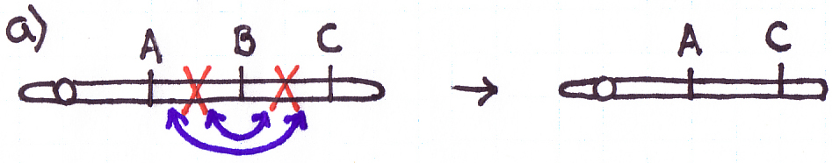
a) Deletions arise when both breaks are on one chromosome. If the ends are joined in this way the piece of DNA with the B gene on it does not have a centromere and will be lost during the next cell division.

-----------------------------------------------------------------------------------------------------
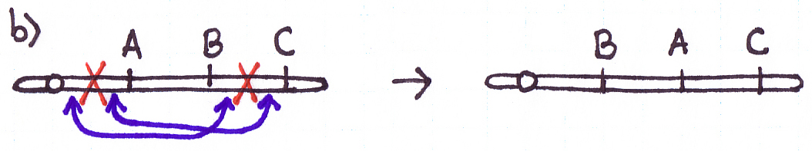
b) Inversions also occur when both breaks are on one chromosome. If the ends are joined in this way, part of the chromosome is inverted. This example shows a paracentric inversion, named because the inverted section does not include the centromere (para = beside). If the breaks occur on different chromosome arms the inverted section includes the centromere and the result is a pericentric inversion (peri = around).

-----------------------------------------------------------------------------------------------------
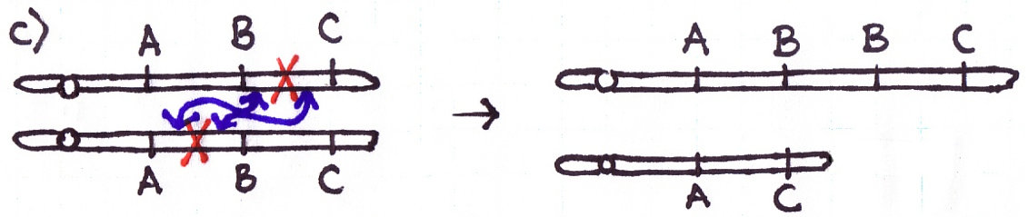
c) Duplications can occur from two DNA breaks at different places in sister chromatids (in a replicated chromosome). The ends are joined together incorrectly to give a chromosome with a duplication (two “B” regions as shown above). Note: the reciprocal product has a deletion.

-----------------------------------------------------------------------------------------------------
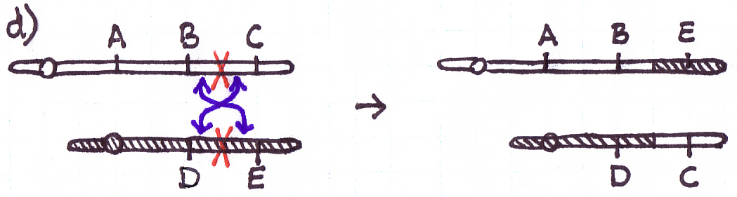
d) Translocations result from two breaks on different chromosomes (not homologs) and incorrect rejoining. This example shows a reciprocal translocation - two chromosomes have 'swapped' arms, the E gene is now part of the white chromosome and the C gene is now part of the shaded chromosome. Robertsonian translocations are those rare situations in which all of the genes end up together on one chromosome and the other chromosome is so small that it is typically lost.
-----------------------------------------------------------------------------------------------------

9.2.3 Cause #2: Incorrect Crossovers During Meiosis
Meiotic crossovers occur at the beginning of meiosis for two reasons. They help hold the homologous chromosomes together until separation occurs during anaphase I (see Chapter 2). They also allow recombination to occur between linked genes (see Chapter 7). The event itself takes place during prophase I when a double strand break on one piece of DNA is joined with a double strand break on another piece of DNA and the ends are put together (Figure 9.7a). Most of the time the breaks are on non-sister chromatids and most of the time the breaks are at the same relative locations.
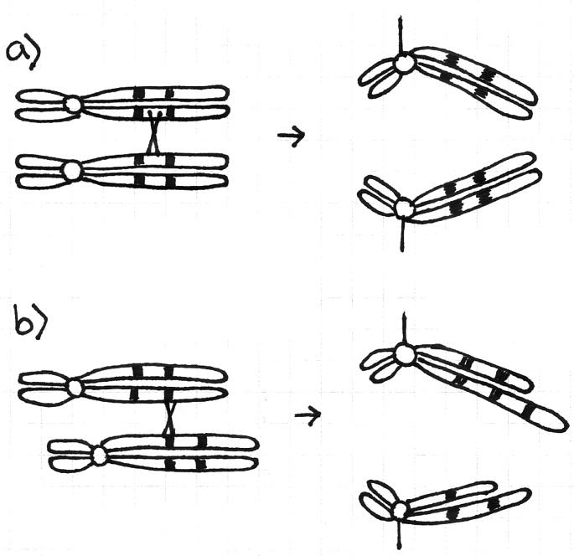 | Figure 9.7 Errors during meiotic crossovers can cause duplications and deletions. This diagram shows homologous chromosomes pairing in prophase I and then separating in anaphase I. The shaded boxes are alu transposable elements. a) The homologous chromosomes pair properly, a crossover occurs, and all four chromatids in anaphase I are normal. b) The pairing is incorrect, a crossover occurs in the misspaired region, and in anaphase I one chromatid has a duplication and another has a deletion. (Original-Harrington-CC:AN)
Problems occur when the wrong pieces of DNA are matched up along the chromosomes during crossover events. This can happen if the same or similar DNA sequence is found at multiple sites on the chromosomes (Figure 9.7b). For example, if there are two Alu transposable elements on a chromosome. When the homologous chromosomes pair during prophase I the wrong Alu sequences might line up. A crossover may occur in this region. If so, when the chromosomes separate during anaphase I one of the chromatids will have a duplication and one will have a deletion. Ultimately, of the four cells produced by this meiosis, two will be normal, one will have a chromosome with extra genes, and one will have a chromosome missing some genes. Errors of this type can also cause inversions and translocations.

9.2.4 Consequence #1 - Rearrangements Show Abnormal pairing at Meiosis
Homologous regions of chromosomes pair at meiosis I (prophase I). With rearranged chromosomes this can lead to visible abnormalities and segregation abnormalities.
Deletion chromosomes will pair up with a normal homolog along the shared regions and at the missing segment, the normal homolog will loop out (nothing to pair with) to form a deletion loop. This can be used to locate the deletion cytologically. The deleted region is also pseudo-dominant, in that it permits the mutant expression of recessive alleles on the normal homolog. Deletion mutations don’t revert - nothing to replace the missing DNA.
Figure 9.8
A paracentric inversion pairing at meiosis. A crossover within the loop causes the production of an acentric and a dicentric chromatids which leads to deletion product..
(Original-Locke-CC:AN)
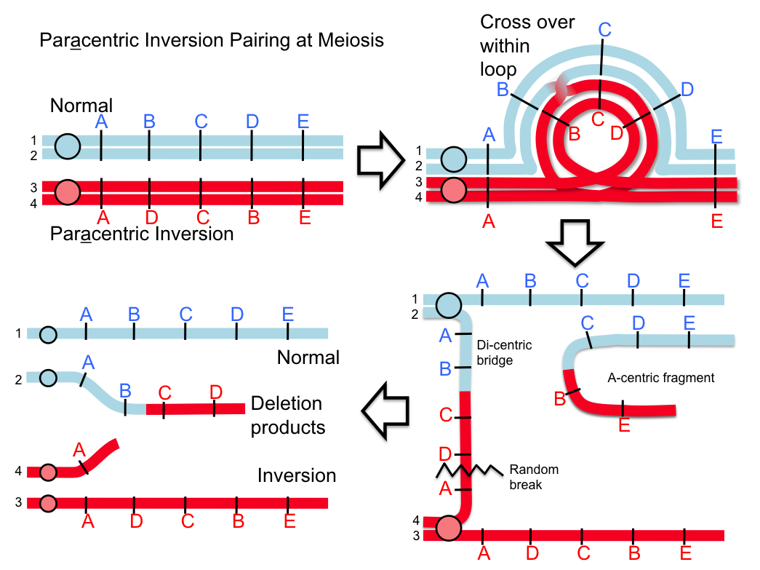
When an inversion chromosome is paired up in meiosis there is an inversion loop formed. If there is a crossover within the loop then abnormal products will result and abnormal, unbalanced gametes will be produced. For example, a crossover event within the loop of a paracentric inversion will lead to a di-centric product that will break into deletion products and produce unbalanced gametes (Figure 9.8n). Similarly, with a pericentric inversion, a crossover event leads to duplicate/deletion products that are unbalanced (Figure 9.9n).
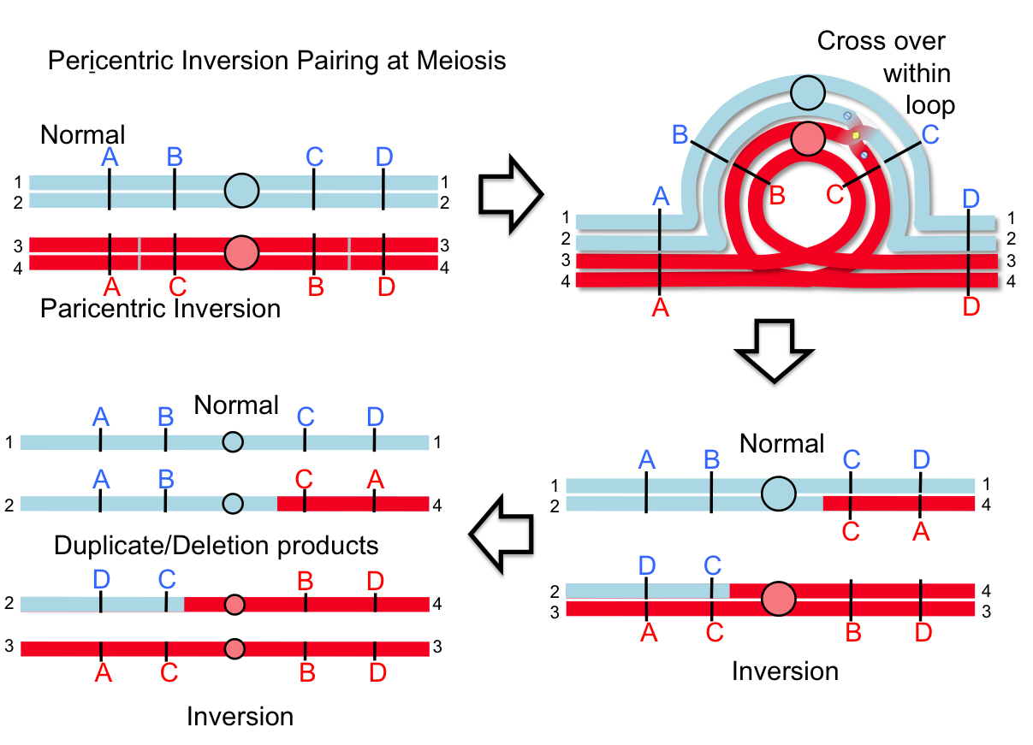
Figure 9.9
A pericentric inversion pairing at meiosis. A crossover within the loop causes the production of duplicate and deletion products.
(Original-Locke-CC:AN)
If joined with a normal gamete, they will result in an unbalanced zygote, which are usually lethal. The consequence for this is that crossover products (recombinants) are lost and thus inversions appear to suppress crossovers within the inverted region.
Note: with both types of inversions, crossovers outside the loop are possible and fully viable as they don’t alter the gene balance.
Duplications also produce a cytologically visible loop at meiotic pairing. Duplications can revert at a relatively high frequency by unequal crossing over. Duplicated genes offer new possibilities for mutational divergence followed by natural selection in the course of evolution.
For translocations, a consequence for the two chromosomes involved is that when they pair at meiosis both replicated chromosome pairs will be together, which can be seen cytologically as a tetrad. This tetrad can segregate in three ways. Two of which are shown below. This set of paired, replicated chromosomes can segregate as Alternate (balanced) where both normal and both translocated chromosomes go to the same polls. Or the chromosomes can segregate as Adjacent-1 (unbalanced) where the normal and translocation chromosomes segregate as shown below. Each of these possibilities is approximately equally frequent and thus only about half the time do the gametes end up unbalanced (Figure 10n).
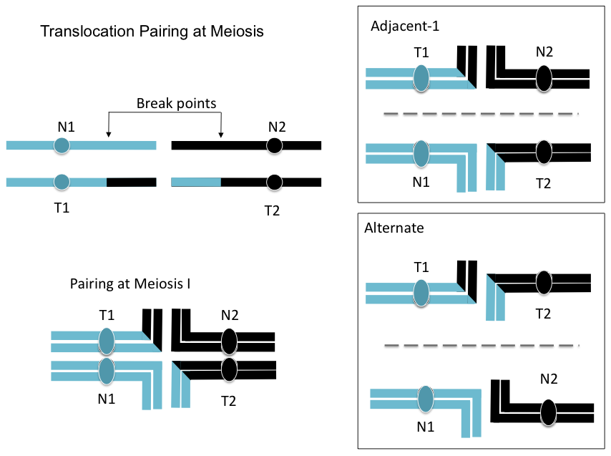
Figure 9.10
A reciprocal translocation pairing at meiosis. There are two main avenues for segregation: Adjacent-1 and Alternate. Adjacent-1 results in duplication and deletion for part of the chromosome segments. Alternate doesn’t.
(Original-Locke-CC:AN)

9.2.5 Consequence #2: Decreased Viability
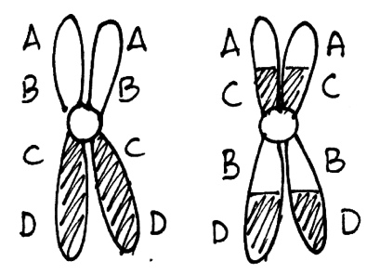
All of the chromosome rearrangements shown above produce functional chromosomes. Each has one centromere, two telomeres, and thousands of origins of replication. Because inversions and translocations do not change the number of genes in a cell or organism they are said to be balanced rearrangements. Unless one of the breakpoints occurred in the middle of a gene the cells will not be affected. On the other hand, deletions and duplications are unbalanced rearrangements. The larger they are (more genes involved) the more disruption they cause to the proper functioning of the cell or organism. As explained in Section 9.1.2 above having too much or too little gene action for a large number of genes can disrupt the cellular metabolism to generate a phenotype or reduce viability.

9.2.6 Consequence #3: Decreased Fertility
Figure 9.11
An unrearranged chromosome (left) and a homolog with a pericentric inversion (right).
(Original-Harrington-CC:AN)
Recall that during meiosis I homologous chromosomes pair up. If a cell has a chromosome with a rearrangement this chromosome will have to pair with its normal homolog.
Cells heterozygous for balanced rearrangements actually have more difficulties in prophase I. Consider the chromosomes shown in Figure 9.11n. There are different ways they might pair during prophase I - one is shown in Figure 9.12n. But if a crossover occurs in the inverted region the result will be unbalanced gametes. Embryos made with unbalanced gametes rarely survive. The consequence is that the heterozygous organism will have reduced fertility.
Figure 9.12
Meiosis in a cell heterozygous for the chromosomes shown in Figure 9.11. Note that of the four gametes one has a deletion of the A gene and a duplication of the D gene while another gamete has a duplication of A and a deletion of D.
(Original-Harrington-CC:AN)
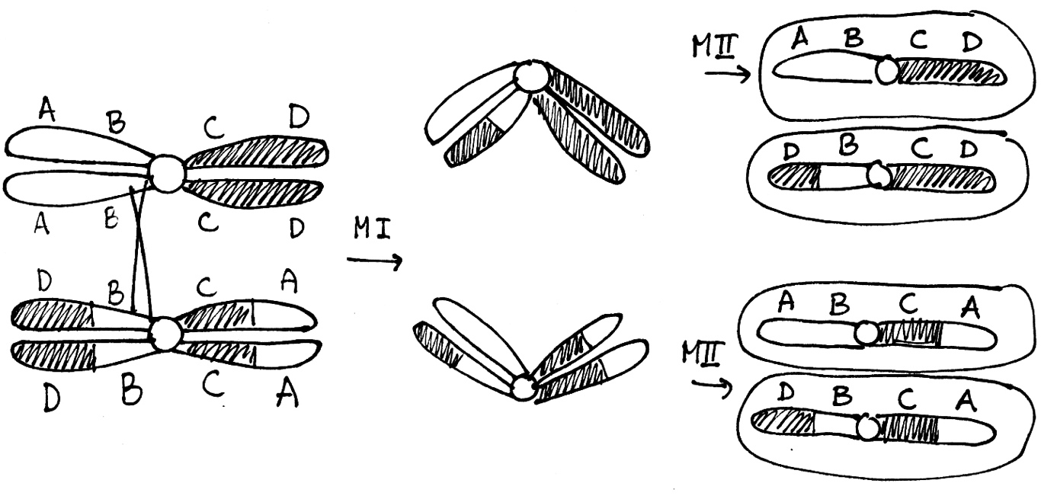
Note that an organism homozygous for this inversion chromosome will not be affected in this way because no loops are formed. The chromosomes can pair along their entire length and crossovers will not produce any unbalanced gametes. This is a general property of inversions and translocations. In heterozygotes there are problems during meiosis resulting in a lot of the gametes being unbalanced and an overall reduction in fertility. In homozygotes the rearranged chromosomes pair with one another just fine and there is no effect on fertility.

9.2.7 Consequence #4: Cancer
Figure 9.13
Duplicated genes can mutate without compromising the viability of the organism. Occasionally the result is a new gene. (Original-Harrington-CC:AN)
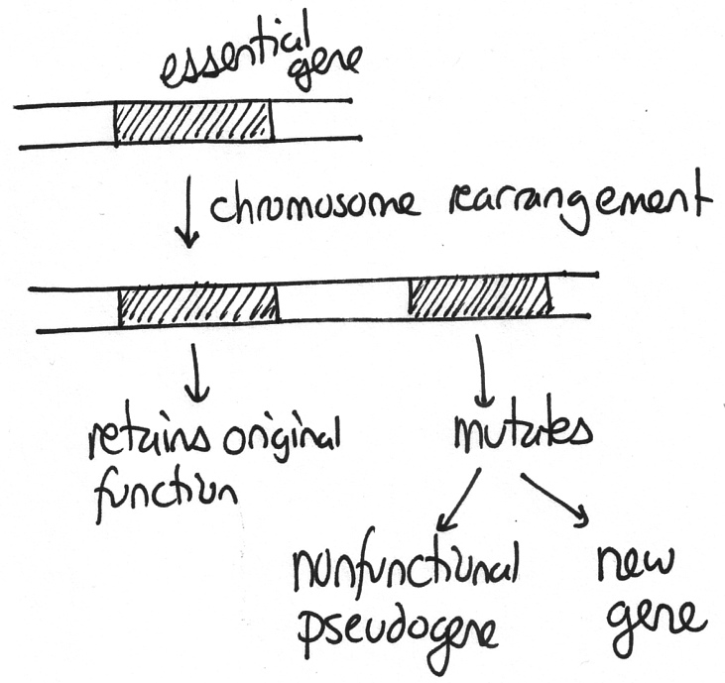
Some chromosome rearrangements have breakpoints within genes leading to the creation of hybrid genes – the first part of one gene with the last part of another. If the hybrid gene inappropriately promotes cell replication, the cell can become cancerous. An example of this is shown in Figure 9.1 where the chromosomes are from a patient with leukemia caused by a translocation between chromosomes 9 and 22 (the red and green spots side-by-side).

9.2.8 Consequence #5: Evolution
Those chromosome changes that duplicate genes are important for evolution. If an organism has an extra copy of important genes, one gene can be retained for their original function while others can mutate and potentially acquire new functions (Figure 9.13n). An example of this is the multiple copies of the globin genes found in mammals (see Figure 12.13).
Chromosome rearrangements that decrease fertility are also important for the origin of new species. If a rearrangement, such as the inversion shown in Figure 9.11n, becomes common in a small isolated population, that population has 100% fertility if they mate within their group, but a reduced fertility if they mate with members of the larger population. As rearrangements accumulate the small population will become more and more reproductively isolated. When members are incapable of forming viable, fertile offspring with the original population the group will have become a new species.

9.3 Chromosome Abnormalities in Humans
The problems described above can affect all eukaryotes, unicellular and multicellular. To better understand the consequences let us consider those that affect people. As you will recall from Figure 2.12, humans are 2n=46. The convention when describing a person's karyotype (chromosome composition) is to list the total number of chromosomes, then the sex chromosomes, and then anything out of the ordinary. Most of us are 46,XX or 46,XY. What follows are some examples of chromosome number and chromosome structure abnormalities.

9.3.1 Down Syndrome
The most common chromosome number abnormality is trisomy-21 or, as it is more commonly known, Down syndrome. Having an extra copy of the smallest human chromosome, chromosome 21, causes substantial health problems.It is present in about 1 in 800 births. Infants with this condition have three copies of chromosome 21 rather than the normal two. Don't confuse trisomy - having three copies of one chromosome (i.e. 2n+1) with triploidy - having three entire chromosome sets (3x; see Section 2.6.) Females with trisomy-21 are 47,XX,+21 while males are 47,XY,+21. In general, people with Down syndrome are 47,sex,+21 where the word 'sex' signifies that the sex chromosomes may be XX or XY.
Trisomy-21 may arise from a nondisjunction event during meioisis in either parent or during mitosis very early during embryogenesis. However, most cases are due to a first division non-disjunction event occurring in the female parent (Figure 9.14n).
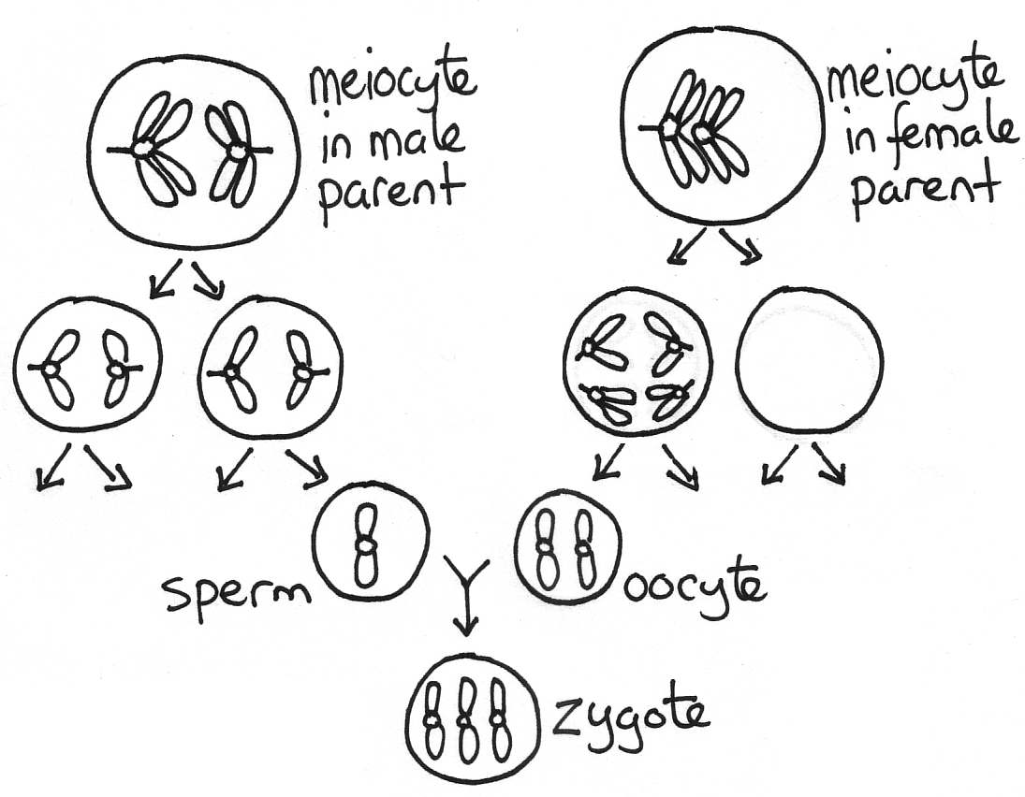
Having an extra copy of the smallest human chromosome, chromosome 21, causes substantial health problems. People with Down syndrome have various degrees of intellectual disability and often have other health problems such as heart defects. The disease was first described by John Down in 1866 but it was not until 1959 when its chromosomal basis was discovered. Current research suggests that at least some of the mental problems are due to having three copies of the DYRK gene on chromosome 21. This gene is active in the brain and there is evidence from humans and from mice that neurons are damaged if there is too much DYRK protein synthesized.
Figure 9.14 This diagram shows the errors during chromosome segregation that cause Down syndrome during meiosis in both parents and fusion of the gametes. Note that the cells that begin meiosis are called meiocytes and that this diagram only shows one of the four cells produced by meiosis. Meiosis occurred properly in the male parent but there was a nondisjunction event in the female parent in anaphase I. (Original-Harrington-CC:AN)

9.3.2 XYY and XXX
While fetuses trisomic for one of the other larger autosomes seldom survive to term, the situation is quite different for the sex chromosomes. Approximately 1 in 1000 males have an extra Y chromosome and yet most are unaware of it! There is little harm in having two Y chromosomes because they have relatively few genes. Similarly, 1 in 1000 females have an extra X chromosome. This situation is also relatively harmless although for a different reason. Normally in female mammals one of the two X chromosomes is inactivated in each cell so that there can be genetic balance (Figure 9.15n and see Section 3.5.2). In 46,XX females one of the X chromosomes is inactivated while in 47,XXX females two are.
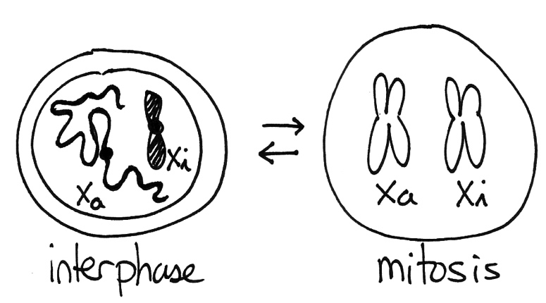 | Figure 9.15  A simplified view of dosage compensation in mammals. Because females have more X chromosomes than males in females one X chromosome is marked as inactive (X_{i}). It is replicated and transmitted during cell division but most of its genes are silent. It appears as a condensed mass called the Barr body within the interphase nucleus.  (Original-Harrington-CC:AN)

9.3.3 Turner Syndrome
Monosomy (2n-1) for autosomal chromosomes does occur at conception but these embryos almost never survive to term. Similarly, embryos that are 45,Y are also non-viable because they lack many essential genes found on the X chromosome. The only viable monosomy in humans is 45,X, also known as Turner syndrome. These people are phenotypically female because they do not have a Y chromosome (see Section 2.5.2). They are viable because in females only one X is active in most cells anyways. People with this condition do have health problems though: they are shorter than average, they have an elevated risk of heart defects, and they are infertile.
The reason for the health problems is that there are a few genes that are found on both the X and the Y chromosome. Because these genes are found in two copies in both XY males and XX females they are in what is called the pseudoautosomal region. This region escapes X chromosome inactivation. One of the genes in this region is called SHOX. It makes a protein that promotes bone growth. 46,XX and 46,XY people have two functioning copies and have average height. People with 47,XYY and 47,XXX genomes have three copies and are taller than average. And people with 45,X have one copy and are short. It is the single copy of SHOX and a few of the other genes in the pseudoautosomal region that causes health problems for women with Turner syndrome.
The reason for the infertility is that the X chromosome inactivation system only acts in somatic cells - it is not needed in the germline cells. Ovaries naturally have two functional X chromosomes. Women with Turner syndrome can not perform oogenesis because this process only works if there are two active X chromosomes. Recently, it has become possible for these women to become pregnant with donated eggs and in vitro fertilization.

9.3.4 Klinefelter Syndrome
There are four common sex-chromosome aneuploidies: 47,XYY, 47,XXX, 45,X, and 47,XXY. This last situation is known as Klinefelter syndrome. These people are male (because they have a Y chromosome) and tall (because they have three SHOX genes). They do not have health problems because the X chromosome inactivation system is independent of sex. In the embryonic nuclei the X chromosome are counted and all but one are shut down. It doesn't matter whether the embryo is male or female. Men with Klinefelter syndrome have a Barr bodies in their nuclei, the same as 46,XX females. They do have fertility problems because there are two active X chromosome in their testes and this interferes with spermatogenesis. They make enough sperm to conceive children using intracytoplasmic sperm injection though.

9.3.5 Cri-du-Chat Syndrome
Cri-du-chat syndrome occurs when a child inherits a defective chromosome 5 from one parent (Figure 9.16n). This condition is rare - it is present in only 1 in 20 000 to 1 in 50 000 births but it does account for 1% of cases of profound intellectual disability. The specific defect is a deletion that removes 2 Mb or more from the tip of the short arm of the chromosome. In most cases the deletion is the result of a chromosomal rearrangement in one of the parent's germ line cells. People with cri-du-chat have a karyotype of 46,sex,deletion(5).
As with Down syndrome this condition is associated with intellectual disability and other health problems. These problems include an improperly formed larynx which leads to infants making high pitched cat-like crying sounds (hence the name "cry of the cat"). It is suspected that at least some of the intellectual disability phenotype is due to having only a single copy of the CTNND2 gene. This gene is active during embryogenesis and makes a protein essential for neuron migration. Down syndrome and cri-du-chat syndrome are two examples of the need for genomes to contain the proper number of genes. Having too many copies of key genes (Down syndrome) or too few (cri-du-chat syndrome) can lead to substantial developmental problems.
Figure 9.16
A boy with cri-du-chat syndrome. The pictures were taken at 8 months (A), 2 years (B), 4 years (C), and 9 years (D).
(Wikipedia-Paola Cerruti Mainardi-CC:AN)

9.3.6 Inversion(9)
The most common chromosome rearrangements in humans are inversions of chromosome 9. About 2% of the world's population is heterozygous or homozygous for inversion(9). This rearrangement does not affect a person's health because the genes on the chromosome are all present - all that has changed is their relative locations. Inversion(9) is different from deletion(5) in two main respects. As mentioned above because it is a balanced rearrangement it does not cause harm. And because of this nearly everyone with an inversion(9) chromosome has inherited it from a parent who had inherited it from one of their parents and so on. In contrast, most cases of deletion(5) are due to new mutations occurring in a parent.

9.4 Diagnosing Human Chromosome Abnormalities

9.4.1 Bright Field Microscopy
How can we confirm that a person has a specific chromosomal abnormality? The first method was simply to obtain a sample of their cells, stain the chromosomes with Giemsa dye, and examine the results with a light microscope (Figure 9.17n). Each chromosome can be recognized by its length, the location of its centromere, and the characteristic pattern of purple bands produced by the Giemsa. For example, if mitotic cells from a person consistently contained forty seven chromosomes in total with three chromosome 21s this would be indicative of Down syndrome. Bright field microscopy does has its limitations though - it only works with mitotic chromosomes and many chromosome rearrangements are either too subtle or too complex for even a skilled cytogeneticist to discern.
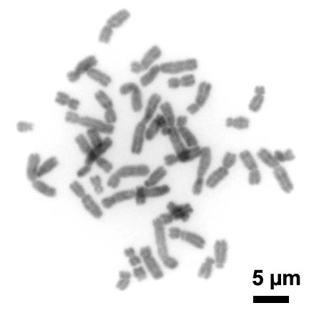 | Figure 9.17  Human chromosomes. One way to obtain chromosomes is to take a blood sample, culture the cells for three days in the presence of a T-cell growth factor, arrest the cells in metaphase with a microtubule inhibitor, and then drop the cells onto a slide. The cells burst and the chromosomes stick to the slide. The chromosomes can then be stained or probed. Because the cells are in metaphase it is possible to see 46 replicated chromosomes here. There will be dozens of collections of chromosomes like this over the entire slide.  (Wikipedia-Steffen Dietzel-CC:AS)

9.4.2 Fluorescence In Situ Hybridization
The solution to these problems was fluorescence in situ hybridization (FISH). The technique is similar to a Southern blot in that a single stranded DNA probe is allowed to hybridize to denatured target DNA (see Section 8.6). However, instead of the probe being radioactive it is fluorescent and instead of the target DNA being restriction fragments on a nylon membrane it is denatured chromosomes on a glass slide. Because there are several fluorescent colours available it is common to use more than one probe at the same time. Typically the chromosomes are also labeled with a fluorescent stain called DAPI which gives them a uniform blue colour. If the chromosomes have come from a mitotic cell it is possible to see all forty six of them spread out in a small area. Alternatively, if the chromosomes are within the nucleus of an interphase cell they appear together within a large blue circle.

9.4.3 Using FISH to Diagnose Down Syndrome
Most pregnancies result in healthy children. However in some cases there is an elevated chance that the fetus has trisomy-21. Older women are at a higher risk because the non-disjunction events that lead to trisomy become more frequent with age. The second consideration is what the fetus looks like during an ultrasound examination. Fetuses with trisomy-21 and some other chromosome abnormalities have a swelling in the back of the neck called a nuchal translucency. If either or both factors is present the woman may choose amniocentesis. In this test some amniotic fluid is withdrawn so that the fetal cells within it can be examined. Figure 9.18n shows a positive result for trisomy-21. Based upon this image the fetus has two X chromosomes and three chromosome 21s and therefore has a karyotype of 47,XX,+21.

Figure 9.18
Confirmation of Down syndrome in a fetal cell. This diagram is based upon actual results. The DNA has been stained blue with DAPI. A red fluorescent probe is binding to the centromeres of chromosome 21 (shown here as filled circles). A green fluorescent probe is binding to the centromeres of the X chromosome (open circles). Source: Figure 4 in Antonarakis, S. E. et al. 2004. Chromosome 21 and Down syndrome: From genomics to pathophysiology. Nature Reviews Genetics 5:725-738 PubMed ID: 15510164.
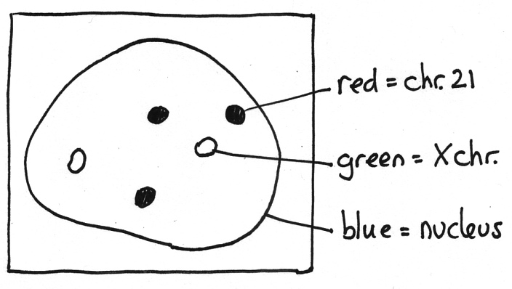

9.4.4 Using FISH to Diagnose Cri-du-Chat Syndrome
A physician may suspect that a patient has a specific genetic condition based upon the patient's physical appearance, mental abilities, health problems, and other factors. FISH can be used to confirm the diagnosis. For example, Figure 9.19n shows a positive result for cri-du-chat syndrome. The probes are binding to two long arms of chromosome 5 but only one short arm. One of the chromosome 5s must therefore be missing part of its short arm.

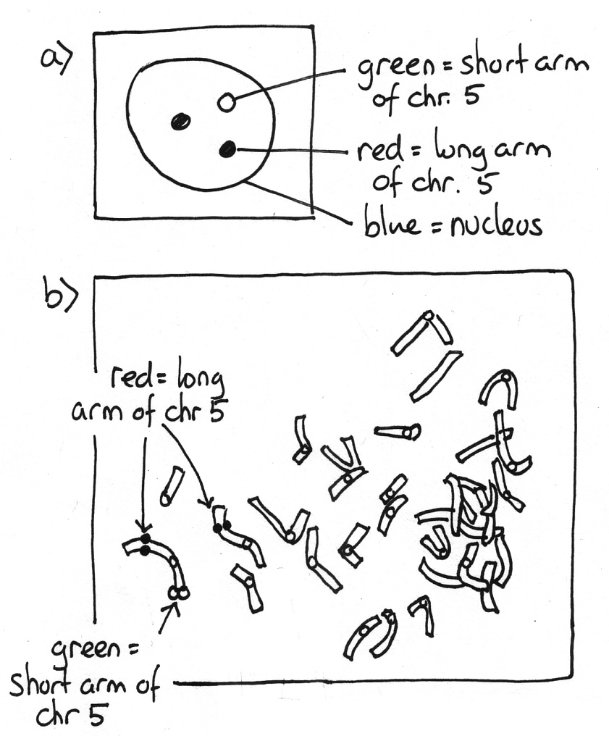 | Figure 9.19  A positive result for cri-du-chat syndrome. This diagram is based upon actual results. Cells from a patient's blood were prepared to show an interphase nucleus (a) and mitotic chromosomes (b). The DNA has been coloured blue with DAPI. The green fluorescent probe is binding to the tip of the short arm of chromosome 5 (shown here as open circles). This is the region absent in cri-du-chat. The red fluorescent probe is binding to the middle of the long arm of the same chromosome (filled circles). This probe is used as a control. Source: Figure 1 in Fang J.-S. et al. 2008 Cytogenetic and molecular characterization of three-generation family with chromosome 5p terminal deletion. Clinical Genetics 73:585-590 PubMed ID: 18400035.

9.4.5 Newer Techniques
FISH is an elegant technique that produces dramatic images of our chromosomes. Unfortunately, FISH is also expensive, time consuming, and requires a high degree of skill. For these reasons, FISH is slowly being replaced with PCR and DNA chip based methods. Versions of these techniques have been developed that can accurately quantify a person's DNA. For example a sample of DNA from a person with Down syndrome will contain 150% more DNA from chromosome 21 than the other chromosomes. Likewise DNA from a person with cri-du-chat syndrome will contain 50% less DNA from the end of chromosome 5. These techniques are very useful if the suspected abnormality is a deletion, a duplication, or a change in chromosome number. They are less useful for diagnosing chromosome inversions and translocations because these rearrangements often involve no net loss or gain of genes.

In the future all of these techniques will likely be replaced with DNA sequencing. Each new generation of genome sequencing machines can sequence more DNA in less time. Eventually it will be cheaper just to sequence a patient's entire genome than to use FISH or PCR to test for specific chromosome defects.

___________________________________________________________________________________________

Summary:
- Errors during anaphase in mitosis or meiosis can lead to trisomy and other forms of aneuploidy.
- Errors during the repair of DNA breaks or during meiotic crossing over can lead to chromosome rearrangements.
- Five common forms of aneuploidy in humans are 47,sex,+21 (Down syndrome), 47,XYY, 47,XXX, 45,X (Turner syndrome) and 47,XXY (Klinefelter syndrome).
- Deletion(5) causes a serious condition (cri-du-chat syndrome) because deletions are unbalanced chromosome rearrangements.
- Inversion(9) causes few health consequences because inversions are balanced chromosome rearrangements.
- Bright field microscopy can be used to detect chromosome number abnormalities and some chromosome rearrangements.
- Fluorescence in situ hybridization can be used to detect all types of chromosome abnormalities.
- PCR and DNA chip based techniques can be used to detect chromosome number abnormalities, deletions, and duplications.

Key terms:

origin of replication
telomere
centromere
non-disjunction
euploid
aneuploid
balanced
unbalanced
first division nondisjunction
second division nondisjunction
double strand break
nonhomologous end joining
DNA repair system
chromosome rearrangement
deletion
inversion
paracentric inversion
pericentric inversion
tandem duplication
translocation
reciprocal translocation
Robertsonian translocation
meiotic crossover
deletion loop
karyotype
46,XX
46,XY
47,sex,+21 (Down syndrome)
trisomy
47,XYY
47,XXX
monosomy
45,X (Turner syndrome)
pseudoautosomal region
47,XXY (Klinefelter syndrome)
46,sex,deletion(5)
(cri-du-chat syndrome)
46,sex,inversion(9)
bright field microscopy
Giemsa stain
fluorescence in situ hybridization
fluorescent probe
DAPI stain
amniocentesis

Study Questions:

9.1 Make diagrams showing how an improper crossover event during meiosis can lead to: (a) an inversion or (b) a translocation.

9.2 Make a diagram showing how a nondisjunction event can lead to a child with a 47,XYY karyotype.

9.3 How many Barr bodies would you expect to see in cells from people who are: (a) 46, XY, (b) 46,XX, (c) 47, XYY, (d) 47,XXX, (e) 45,X, and (f) 47,XXY ?

9.4 Why can people survive with trisomy-21 (47,sex,+21) but not monosomy-21 (45,sex,-21)?

9.5 If Drosophila geneticists want to generate mutant strains with deletions they expose flies to gamma rays. What does this imply about gamma rays?

9.6 What would happen if there was a nondisjunction event involving chromosome 21 in a 46,XY zygote?

9.7 Design a FISH based experiment to find out if your lab partner is a 47,XXX female or a 47,XYY male.

9.8 What would Figure 9.18 look like if it also showed metaphase chromosomes from another cell?

Notes:

Chapter 9 - Answers

9.1 a) As in Figure 9.7 homologous chromosomes pair during prophase I. The shaded boxes are regions of sequence similarity, for example Alu transposable elements. A crossover occurs between two of the Alu elements on the same chromatid leading to a chromosomal inversion.
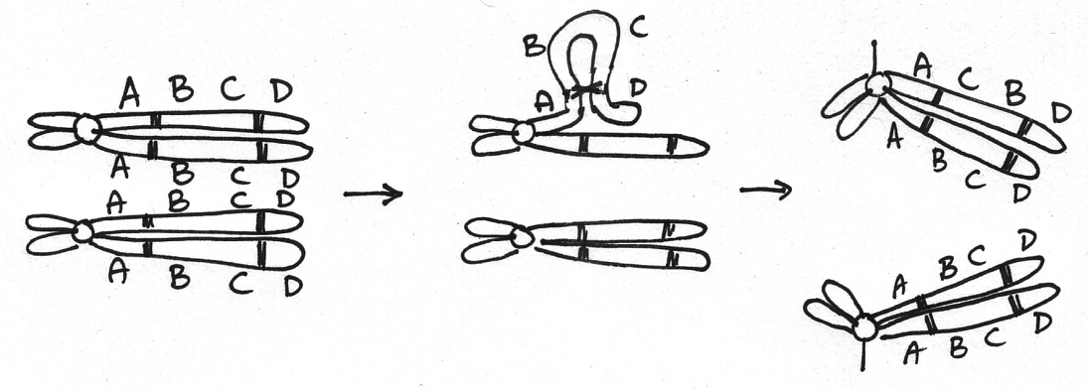

b) A crossover occurs between Alu elements on different chromosomes leading to a chromosomal translocation. Note that the homologous chromosomes are not shown in this figure for simplicity.
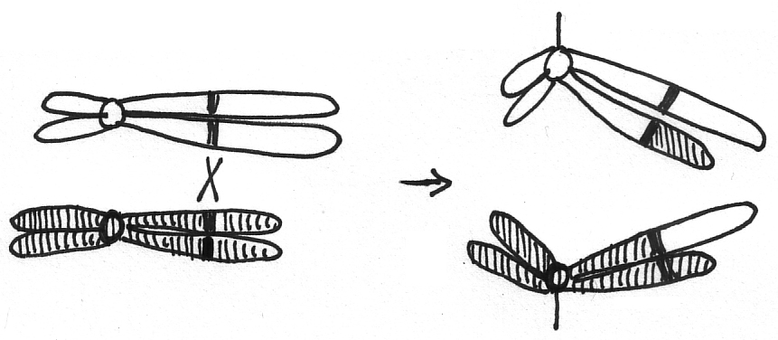
9.2 As in Figure 9.12 there is a nondisjunction event during gamete formation. The larger X chromosomes are shown using open symbols and the smaller Y chromosomes are shown with shaded symbols. A second division nondisjunction event in the male parent leads to a zygote with an XYY karyotype.

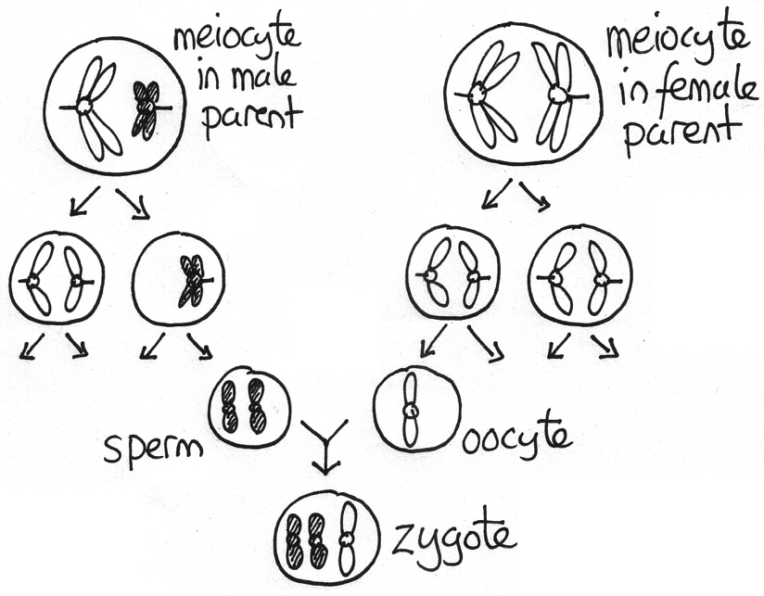
9.3 a) 46, XY - zero Barr bodies, b) 46,XX - one, c) 47, XYY - zero, d) 47,XXX - two,
e) 45,X - zero, f) 47,XXY - one.

9.4 Having a shortage of key proteins is usually more detrimental than having an excess.
9.5 Gamma rays are efficient at causing double strand DNA breaks, which are then more likely to rejoin and produce a deletion.
9.6 At the two cell stage, one of the embryo’s cells will be 45,XY,-21 while the other will be 47,XY,+21. As embryogenesis continues most of the monosomy-21 cells will die and the embryo will ultimately be made of mostly trisomy-21 cells. The child will be born with Down syndrome.
9.7 Obtain permission from the person (and ethical approval from the university), isolate some white blood cells, place the cells on a slide, denature the DNA, hybridize with fluorescent nucleic acid probes specific for the centromeres of the X chromosome and the Y chromosome, observe the results with a fluorescence microscope. If they are XXX there should be three X signals, if XXY, there should be two X signals and one Y in each cell nucleus.
9.8 The results would be similar to Figure 9.19b. There would be 47 chromosomes glowing blue. The centromeres of two of the chromosomes would be glowing green and the centromeres of three other chromosomes would be glowing red.

